Year 3 Optional Homework Autumn Term 2023
This term homework is linked to our topic ‘How did they survive?’
From the 9 tasks below, choose 4 to complete over the whole term. You can choose how you present your learning and we would like you to be creative, have fun and be proud of your learning! We look forward to you sharing your learning with us in school!

Cave Art Story  Can you create a story using cave art? It can be about anything you like but you must tell it through stories.  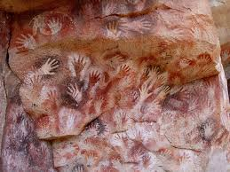 | Rock Cakes  In science, we have been looking at rock types. Find a recipe to make some rock cakes?  Do they have any similarities to real rocks?  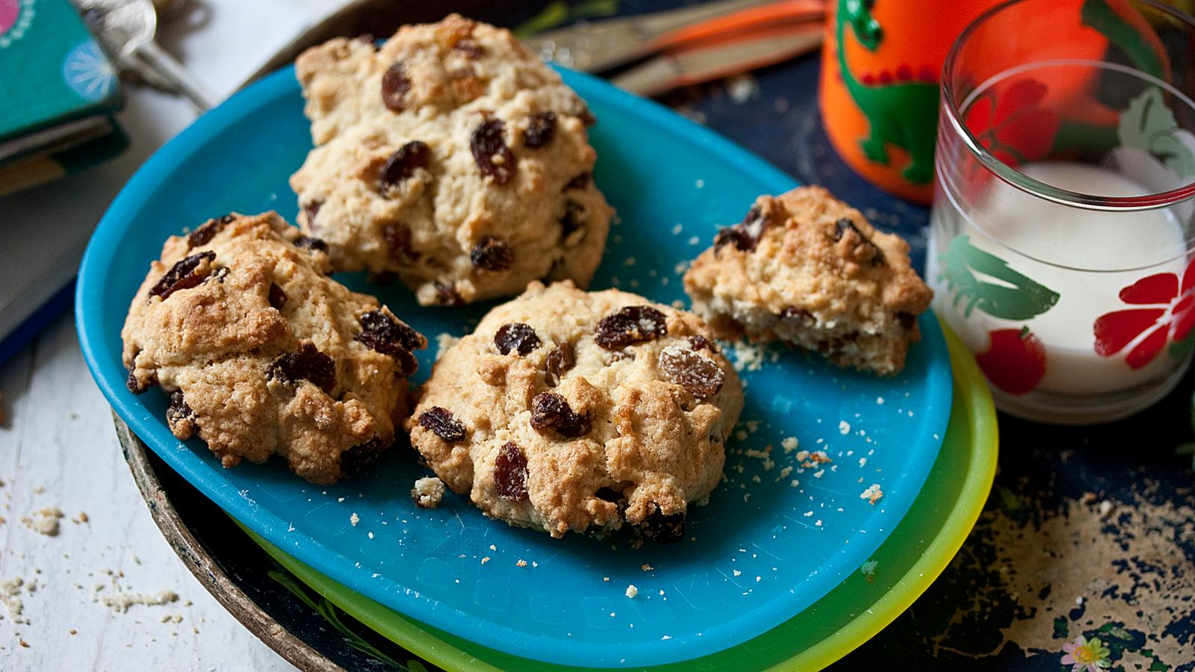 | Amazing Animal Facts  Research animals that live in a different country including their habitat, what they eat and any special adaptations. Present this information any way you wish. This might be a poster, PowerPoint or a book.  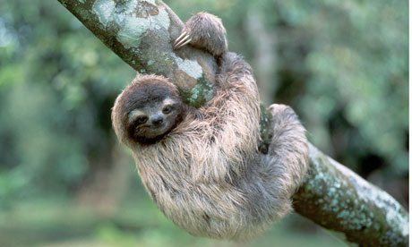
I am a Stone Age hunter/gatherer  Imagine and draw yourself as a Stone Age person with interesting, informative labels. What could you be holding? Where are you standing? (Add a background) | Welcome to our new settlement!  Your new settlement needs new rules to keep everyone happy. What rules would be really important for your new settlement? How do they compare to the charter we made in our class? | Bug Hotel  Design/make a bug hotel/ insect dwelling or tree house for a range of creepy crawlies that live in the local environment.  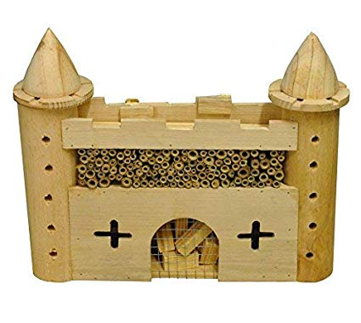
Stone Age Housing  Research, design and make a model of a Stone Age house.  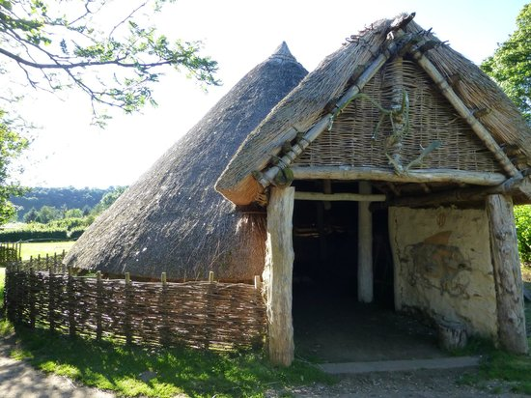 | Stranded  You have been stranded in the Stone Age. Write a diary entry about your experience. Remember to include how you feel, what you can hear, smell, touch or see.  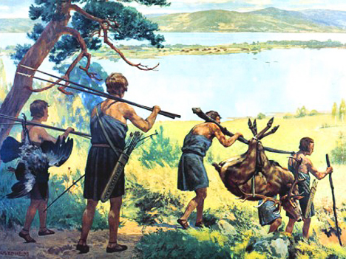 | Animal cakes/cookies  This was the children’s idea! Make cakes with a weird animal theme. This could be marble cakes or have an animal decoration. You could even make animal shaped biscuits. Remember to write up the recipe and include instructions.  