Handwriting at Billingshurst Primary School
Handwriting remains an important life skill as a tool for learning, self-expression, and communicating language. We recognise that children’s ability to handwrite effectively for the rest of their lives depends on the firm foundations established in this primary school.
Our aims are for all children to:
• Learn and practise appropriate handwriting skills at each stage of development, working towards comfortable, cursive handwriting which is legible, fluent and fast.
• Develop as confident ‘hybrid writers’ with the skills to communicate through both handwriting and technology.

Key Terms:
Positional language
An essential part of teaching patterning and letter formation is to ensure that young children really understand positional language when working with pencil and paper.
Terms include: up, down, above, below, under, top, bottom, across, around and between.
Capital or Upper-case letters
Small or Lower-case letters
The base line
This is the continuous line upon which the main bodies of letters rest.
Ascenders
Descenders
These are the correct terms for the parts of letters that extend above or below the letter body. For younger children it is sometimes easier to describe these as Tall and Tail.
x-height or short letters
These are letters without ascenders or descenders, such as m, e, and o.
Letter bodies
The parts of letters which are neither ascenders nor descenders e.g. the rounded parts of b, d and a and the “arches” of m and n.
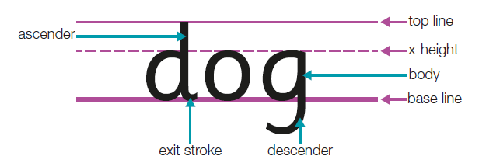
Entry or Lead-in stroke
Letters in a continuous cursive style will begin on the base-line with an entry stroke / lead-in stroke.
Exit stroke or flick
Letters that finish on the baseline often have a final flick in the forwards direction. This provides the potential to join when the child is ready for this step.

Joining strokes and Break letters
The National Curriculum refers to ‘the diagonal and horizontal strokes needed to join letters and letters which adjacent to each other are best left un-joined.’
Diagonal strokes join from letters which finish on the baseline.
Horizontal strokes join from letters which finish at the top.
Break letters are those which when adjacent to each other are best left un-joined.
Continuous cursive / fully joined
In this style, letters begin on the baseline with a lead in stroke. All lower-case letters are joined.

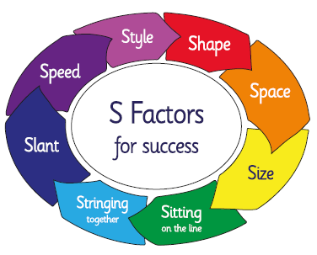

Year Group | NC Objectives | Handwriting Skills Development | Assessment
EYFS | • Uses a pencil and holds it effectively to form  recognisable letters, most of which are correctly  formed.  Early Outcomes: Physical Development 40-60  months  • They write simple sentences which can be read by  themselves and others.  Early Learning Goal 10: Writing: Expected Level  Transition EYFS – Y1:  • sit correctly at a table, holding a pencil  comfortably and correctly  • begin to form lower-case letters in the  correct direction, starting and finishing in  the right place  • form capital letters  • form digits 0-9  • understand which letters belong to which  handwriting ‘families’ (i.e. letters that are  formed in similar ways) and to practise  these. | Developing fine motor skills  Develop patterns and basic letter movements  Letter Formation Families  Teaching the letters in movement groups reduces the learning load and provides for reinforcement of basic movement patterns.  Introduce letter formation families.  The ‘l’ team:  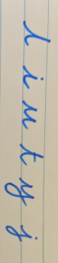  The ‘c’ team:  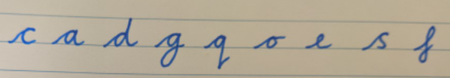  The ‘r’ team:  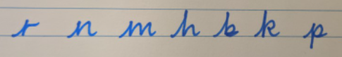  The ‘zig-zag’ team:  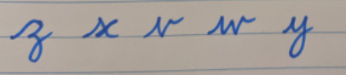  Movements of letters should be practised in many playful ways including painting, modelling, toy lasers, wands, salt trays, dance and music.  The child must be able to sky write the letter movements correctly before any paper and pencil activities begin.  The formation of digits which can be incorporated in the letter formation movement families:  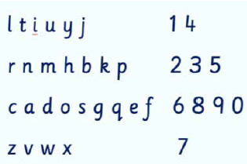  SHAPE: The use of entry and exit strokes  For the majority of children, adding an entry and exit flick to the appropriate letters is manageable and leads quite naturally into joining later on. It is helpful to explain this function of flicks to children so that they are motivated to use them. Examples of joining from everyday life can help the understanding  Capital Letters  It is important to teach the capital letters and their formation quite specifically. Pupils should also be sure of the upper case and lower-case forms of each letter and be able to relate them to one another.  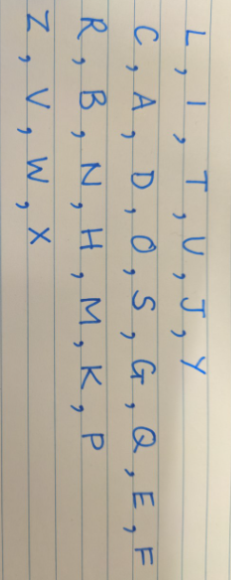
Year 1 | Pupils should be taught to:  • sit correctly at a table, holding a pencil  comfortably and correctly  • begin to form lower-case letters in the  correct direction, starting and finishing in  the right place  • form capital letters  • form digits 0-9  • understand which letters belong to which  handwriting ‘families’ (i.e. letters that are  formed in similar ways) and to practice these.  Children ‘should be taught a joined style as soon as they can form letters securely with the correct orientation’ and ‘understand which letters, when adjacent to each other, are best left unjoined.’ | SHAPE: The use of entry and exit strokes  For the majority of children, adding an entry and exit flick to the appropriate letters is manageable and leads quite naturally into joining later on. It is helpful to explain this function of flicks to children so that they are motivated to use them. Examples of joining from everyday life can help the understanding.  Capital Letters  It is important to teach the capital letters and their formation quite specifically. Pupils should also be sure of the upper case and lower-case forms of each letter and be able to relate them to one another.  SPACE– between letters and words.  There needs to be a small space between letters in a word. Exit flicks and joining strokes can provide this. There needs to be appropriate spaces between words for the sake of legibility. The spaces should  be even, match the size of the writing and be about the same size as one letter o or two – oo. Children need to gradually visualise a suitable space between words, but before this is established, a lolly stick or coffee stirrer can help. Using the traditional ‘Finger space’ isn’t helpful in the long run as fingers grow bigger and writing gets smaller.  SIZE - the relative positioning of letters  If possible, children should begin this stage by  sorting and positioning plastic letters into the three sizing bands: x height/short, ascenders/tall and descenders/tail.  Small/halfway letters/x-height letters e.g. a, e, o, s Tall letters/letters with ascenders e.g. h, l, b, k (plus all capitals) Tailed letters/letters with descenders e.g. p, g, y, j  A visual image helps children understand the 3 levels.  Suggestions are: ● sky/grass or forest/underground ● head/body/legs  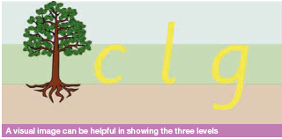  Practising the size families on double lined paper follows next:  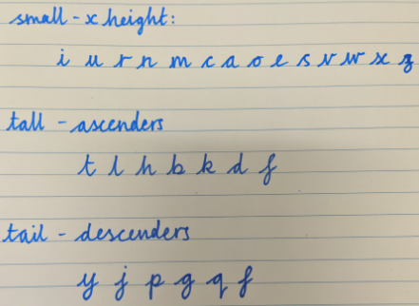  SITTING on the line - Once children are secure in forming letters correctly, they need to learn where to position them. Sitting the letters on the writing line helps legibility. After sitting, the next step is to understand the relative sizing of letters.  A short period using simple double lined paper will help scaffold learning of size and position. As the size of children’s writing will vary, it is advisable to print this format in differing widths and use that most suitable for each child. In Years 1-2, this will need to include 6mm, 5mm and 4 mm spacings between the two lines (see https://nha-handwriting.org.uk/shop/printable-line-guides/ for printable guidelines of varying sizes). Children will need to use their eyes to judge the sizing of ‘tall’ and ‘tail’ letters. Once this awareness of sizing becomes embedded, the child can return to using normal lines.  STRINGING - Joining should be introduced when the previous S Factors are well established. Some children may be ready to join before Year 2 (see below). * It is crucial that ‘starting to join’ is not given elevated esteem or some children will feel pressured to try doing it before they are developmentally ready. | Children who did not meet expected levels in  Physical Development and Writing at ELG will need to be monitored and supported.  At the start of Year 1, staff need to observe  each child writing to assess which are letters are being formed correctly and which are not.  Teachers can assess against the ‘S’ Factors Checklist:  Shape  Space  Size
Year 2 | Children ‘should be taught a joined style as soon as they can form letters securely with the correct orientation’ and ‘understand which letters, when adjacent to each other, are best left unjoined.’  Pupils should be taught to:  • form lower-case letters of the correct size  relative to one another  • start using some of the diagonal and  horizontal strokes needed to join letters and  understand which letters, when adjacent to  one another, are best left un-joined  • write capital letters and digits of the correct  size, orientation and relationship to one  another and to lower case letters  • use spacing between words that reflects  the size of the letters. | STRINGING - Joining should be introduced when the previous S Factors are well established. Some children may be ready to join before Year 2. * It is crucial that ‘starting to join’ is not given elevated esteem or some children will feel pressured to try doing it before they are developmentally ready.  The mechanics of joining:  There are two basic rules for joining.  Diagonal or up the hill joins - Letters which finish on the baseline join diagonally  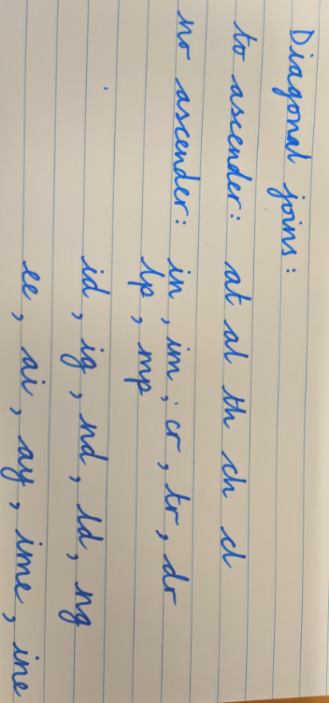  Horizontal or across the bridge joins - Letters which finish at the top join horizontally  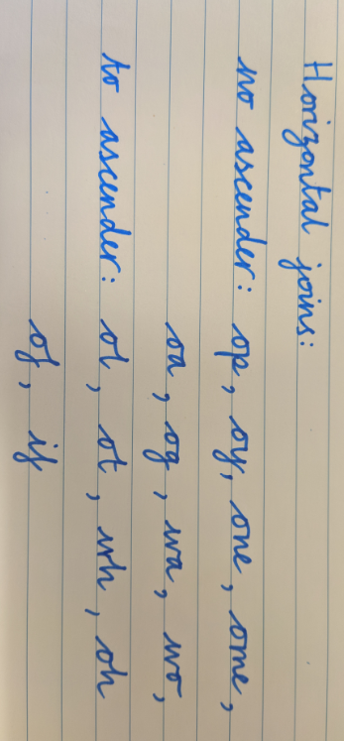  Teachers should introduce the joins both to and from each letter and give the children plenty of practice with short words. This should begin with adjacent letters which occur most frequently e.g., it, he, th, ee. Once learnt, the joins should be applied to the high frequency words, digraphs, trigraphs and consonant clusters required to be learnt in Letters and Sounds.  As soon as children are able to join letters, they should use this for all of their written work so that it gradually becomes automatic.  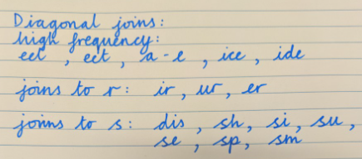  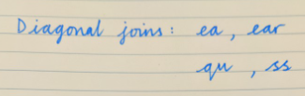  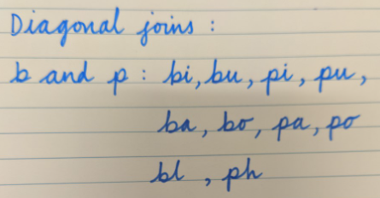  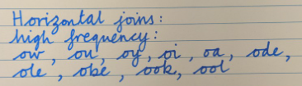  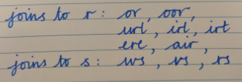  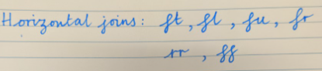  Children who struggle with joining:  There needs to be awareness and understanding that some children struggle with the coordination issues involved in learning to join. For these children, it is advisable to spend the time improving the legibility and fluency of a basic un-joined style. | At the start of Year 2, staff need to observe  each child writing to assess which are letters are being formed correctly and which are not.  Teachers can assess against the ‘S’ Factors Checklist:  Shape  Space  Size  Sitting on the line  Stringing
Year 3 and Year 4 | Pupils should be taught to:  • use the diagonal and horizontal strokes that  are needed to join letters and understand  which letters, when adjacent to one another,  are best left un-joined  • increase the legibility, consistency and  quality of their handwriting [for example,  by ensuring that the downstrokes of letters  are parallel and equidistant; that lines of  writing are spaced sufficiently so that the  ascenders and descenders of letters do not  touch.  Pupils should be using joined handwriting  throughout their independent writing.  Handwriting should continue to be taught,  with the aim of increasing the fluency with  which pupils are able to write down what they  want to say. This, in turn, will support their  composition and spelling. | STRINGING  Using the Year 2 examples as a starting point, children should continue to develop fluency with joining, progressing through the different diagonal and horizontal joins.  Children can move on to practice high frequency joins found in spelling patterns, such as:  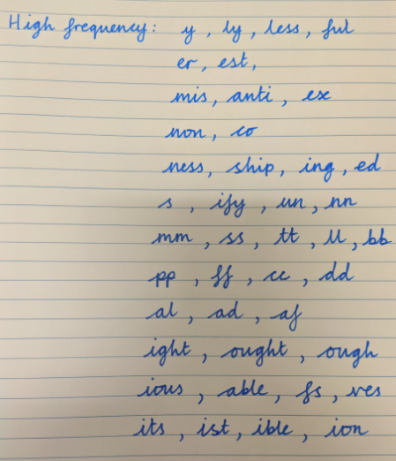  SLANT  A consistent slant helps the appearance of handwriting. A slightly forward slant is a natural movement for right-handers and helps to improve  fluency and speed.  Slant can be practised through writing small words using letters:  l,h,b,I,u,y: hill, little etc. with a focus on parallel down strokes. | At the start of Year 3 and 4, staff need to observe  each child writing to assess which are letters are being formed correctly and which are not.  Teachers can assess against the ‘S’ Factors Checklist:  Shape  Space  Size  Sitting on the line  Stringing
Year 5 and Year 6 | Pupils should be taught to write legibly,  fluently and with increasing speed by:  • choosing which shape of a letter to use  when given choices and deciding whether  or not to join specific letters  • choosing the writing implement that is best  suited for a task.  Pupils should continue to practise  handwriting and be encouraged to increase  the speed of it, so that problems with forming  letters do not get in the way of their writing down what they want to say. They should be  clear about what standard of handwriting is  appropriate for a particular task, for example,  quick notes or a final handwritten version.  They should also be taught to use an unjoined  style, for example, for labelling a  diagram or data, writing an email address, or  for algebra and capital letters, for example,  for filling in a form. | SPEED  Speed and Style are the aspects of handwriting to be secured in Years 5 and 6.  Speed is a measure of automation, so it will not develop until the other S factors are embedded. Children need help in understanding that increasing speed changes writing. More speed can improve rhythm and fluency but too much can cause illegibility.  There needs to be awareness that competent writers have two kinds of handwriting - one which is good quality and is used for more formal purposes and the other - a fast, note-taking ‘rough’ hand which is used when speed is needed.  Building up speed takes short regular practice of appropriate tasks: repeating words, phrases, then sentences and paragraphs.  There are some children who learn to write legibly but will have disabilities which preclude them from writing at speed (e.g. children with cerebral palsy or DCD).  STYLE  Students should be encouraged to develop a style of writing that works for them.  Students can consider changes to their writing style that could increase speed and/or fluency, e.g.  ● Adding loops to g,y,j and possibly f to increase speed and flow.  ● Consider if there are any joins that do not flow well and would be better left unjoined.  ● Be aware that different qualities and speeds of writing are required for different tasks: personal notes, exams, course work, job applications – and adapt accordingly – see list of ideas below.  N.B. They should also be aware of occasions when an unjoined style is appropriate: for labelling diagrams/data, e-mail addresses etc. and be able to use capital letters for form-filling. | Children to self-assess against the ‘S’ Factors Checklist and identify personal target  Teachers can assess against the ‘S’ Factors Checklist and focus on any areas of need identified, using the Year 2, 3 and 4 progression of joining to help with stringing:  Shape  Space  Size  Sitting on the line  Stringing  Slant

Ideas for spelling activities to practise the ‘S’ Factors:
Speed: Note making; address;
Size: Posters;
Style: Posters; labels; headings; letter ‘in role’ as a character e.g. a WW2 Evacuee

