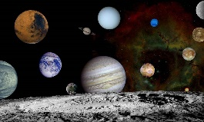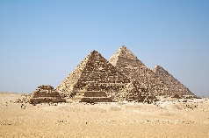**Year 5 Optional Homework Autumn 2023**

**What Lies Beyond…**

Here is your choice of homework tasks.From the activities below, you need to choose 4 to complete over the whole term. The dates when your homework choices should be completed by are: Friday 29th September, Friday 8th October, November 10th and December 8th. The expectation is that you will put in care and effort and complete it to the best of your ability. You can present your work in an appropriate style of your choice – model, booklet, diagram, leaflet etc. It may be word-processed or completed by hand. We look forward to seeing your work and remember to have fun!

|  |  |  |
| --- | --- | --- |
| **Biographical Writing**  Write a biography of a character from a book you are reading. It could be a space scientist, astronaut or historical figure. | **Space rations**  Can you make a snack for an astronaut to take with them to the international space station? It must be healthy and not produce too many crumbs! | **Egyptian Holidays**  Look online (or visit a Travel agent) and create a budget for a family holiday to visit Egypt  and see all the sights. |
| **Data, Data!**  Create an infographic displaying data about our solar system, or anything else space or Egypt related that you can come up with. | **Egyptians or Space Timeline**  Create a timeline of significant events that occurred during the Egyptian or even the making of the solar system. | **Feeling Creative?**  Draw, paint, make a collage or model using different materials inspired by something we’ve been learning about. It could be from a book, science or history (Space + Egypt) |
| **Extra, extra!**  Create a news report about an event you’ve learnt about. This can be written on paper or as a video blog. | **Dear diary….**  Create a diary of any event we have been learning about. Remember – you can record this in any way you see fit – doodles and diagrams are fine. | **Make a rocket**  Design a rocket capable of travelling at least 15 metres. How will it be powered? It’s up to you! |
| **Picture writing**  The people of the Egyptians created their own pictorial/symbol writing system. Can you create your own to write a message to a friend? | **Model Making**  Can you make a model with the title Space or Egypt? Try using recycled household objects and make it as life-like as possible. | **Take Shelter**  Can you make your own space station for living on a particular planet? Think about the conditions and your basic needs. |