# Playdough

## Here’s a simple no cook recipe -

* 2 cups plain flour 
* 2 tablespoons vegetable oil
* ½ cup of salt
* 2 tablespoons of cream of tartar
* 1 to 1.5 cups of boiling water (add bit by bit until it feels right)
* Gel food colouring (optional)
* Few drops of glycerine (optional)

**Method -**

* Mix flour, salt, cream of tartar and oil in a large bowl
* Add food colouring to boiling water and then add to the dry ingredients
* Stir until all combined in a sticky ball
* Allow to cool down and then knead vigorously for a couple of minutes

**Then …**

* Make numerals and shapes
* Make spheres and see who has the most
* Make long and short wiggle snakes

# Billingshurst Primary Academy https://www.billingshurstprimary.org.uk/core/passwords/read_logo/16b1bd93695f0c940ede52343c0558da

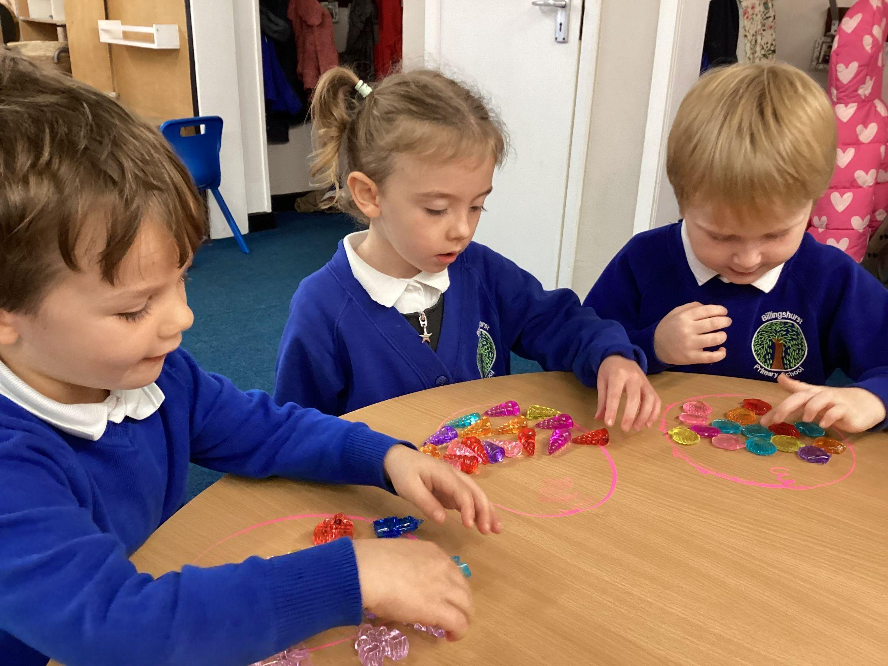

## Supporting your child with Maths

## Information for parents and carers.

# How do children in Reception Learn Maths at Billingshurst Primary Academy?

The children learn mathematical skills through a number of ways:

* **PLAY** and self-discovery through the planned environment
* Talk - asking questions, listening to others
* Thinking
* Problem solving
* Using manipulatives
* Real life learning
* Whole class taught sessions
* Booster groups
* Practical and engaging experiences
* Mastery!

# What is teaching for Mastery?

## Definition of Mastery

At Billingshurst we see teaching for Mastery in maths as allowing pupils to gain a deeper understanding of maths, allowing them to acquire a secure and long-term understanding that helps them make continual progress to move onto more complex topics.

## Teaching for Maths Mastery

We break down maths objectives into the smallest steps, so that every pupil is secure in all new concepts. We focus on teaching for fluency, reasoning and problem solving.

## Fluency -

In Early Years we teach the children to have a deep understanding of number.

**Representing number -**

We want to develop children’s number sense so that they understand the number rather than just recognise the numeral. Children need to understand that numbers can be represented in many ways, not just as a written numeral.

For example…

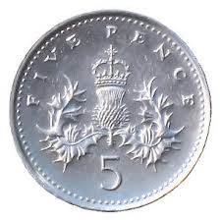 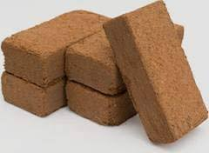

Sometimes children need lots of practice to recognise numbers in different forms.

**Counting -**

When counting, children need to understand that:

* We need to say one number for each object counted (touch counting or one to one counting)
* The final number we say is how many altogether.
* We can count objects in any order and the total stays the same.

**Recognising Amounts -**

Another skill that is very important is recognising small amounts without the need to count them, subitising. Initially this should be

by using concrete objects but as children progress, allowing them to see groups of dots in different arrangements helps them to mentally ‘see’ how many objects are there without needing to count them. This is an important skill when children begin to add or subtract. Using dice is a good way to practise these skills before moving on to different arrangements.

**Understanding that the total stays the same even when the objects move. -**

When children first start to use numbers, they often do not understand that if we move objects into another arrangement the total stays the same. We practise this with many types of objects but a useful tool is using a tens frame (see image below) to be able to move counters around

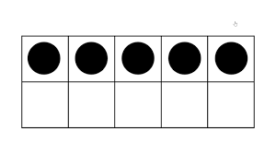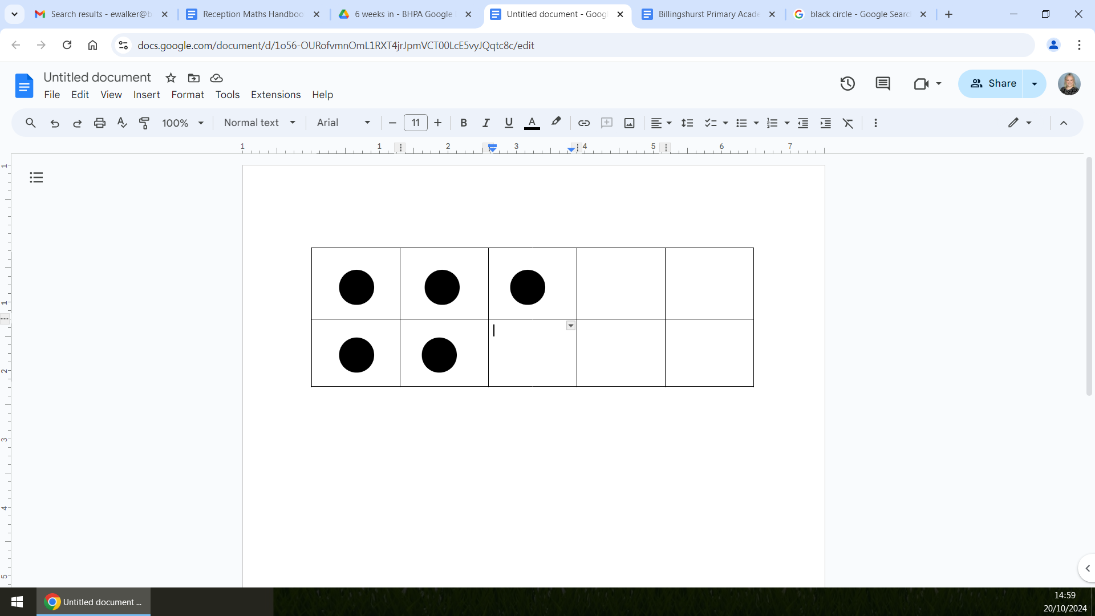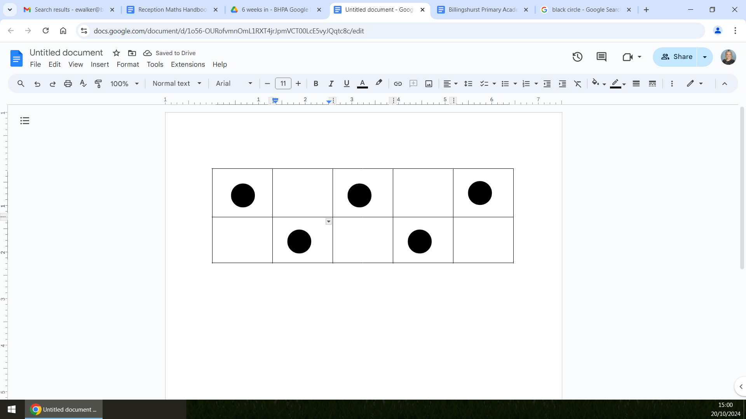

By Becoming fluent in maths facts, it allows our brain to concentrate on higher level skills.

**Games -** 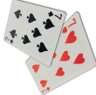

* Jigsaws
* Snap, matching pairs
* Snakes and ladders and other simple dice games 
* Dice - how many spots on the dice? Adding two dice together.
* Bingo, with either numbers or shapes
* Hopscotch

**Food -** 

* Can you cut your toast into 4/2? Can you cut it into rectangles or triangles?
* Setting the table, counting the right amount of settings, knives and forks etc.
* Helping with the cooking by measuring and counting ingredients
* Setting timers
* Positional language at dinner time: what is on the pasta, where are the peas etc?

**Going Shopping -**

* Recognising numbers and reading price tags
* Counting items into baskets
* Finding and counting coins
* Comparing weights. Which is the heaviest?

**Measuring -**

* Are you taller than a …?
* Marking heights on a wall chart
* Cut hand shapes out of paper. How many hands long is your bed?
* Who has the biggest hands?
* How many steps from your bed to the bathroom?

**Shapes -** 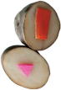

* Cut a potato into shapes. Use them in paint to make pictures.
* Cut out coloured shapes from paper, and arrange into pictures
* Shape hunts around the house.

## Reasoning -

Reasoning in maths helps children to be able to explain their thinking, therefore making it easier for them to understand what is happening in the maths they are doing. It helps them to think about how to solve a problem, explain how they solved it and to think about what they could do differently.

**In Early Years, some examples of reasoning are:**

* Asking the children true or false statements - e.g. if I add 1 to this number it becomes smaller. True or false?
* Spotting incorrect maths e.g. 1,2,4,3,5
* Explaining how we know something or how we worked it out.

## Problem solving -

Problem solving in maths allows children to use their maths skills in lots of contexts and in situations that are new to them. It allows them to seek solutions, spot patterns and think about the best way to do things rather than blindly following maths procedures.

**In Early Years problem solving includes:**

* Spotting, following and creating patterns.
* Estimating amounts of objects
* Predicting how many times they can do something in a minute.
* Sharing objects between different groups, particularly when the amount of groups change and the amount of objects stays the same.
* Finding different ways to split numbers, e.g. 5 could be 5+0, 4+1, 3+2 etc

# The Early Years Foundation Stage Curriculum for Maths. What are the children learning to do in Reception?

The Early Years mathematics curriculum is split into two areas; Number and Numerical Patterns. There are two early learning goals for maths and this is what most children in Reception are expected to be able to do by the end of their first year at school.

**Number**

**Children at the expected level of development will:**

* have a deep understanding of number to 10, including the composition of each number;
* subitise (recognise quantities without counting) up to 5;
* Automatically recall (without reference to rhymes, counting or other aids) number bonds up to 5 (including subtraction facts) and some number bonds to 10, including double facts.

**Numerical patterns -**

**Children at the expected level of development will:**

* Verbally count beyond 20, recognising the pattern of the counting system;
* Compare quantities up to 10 in different contexts, recognising when one quantity is greater than, less than or the same as the other quantity;
* Explore and represent patterns within numbers up to 10, including evens and odds, double facts and how quantities can be distributed equally.

# How You can Support At Home

**Counting -**

* Count steps, coins into a money box, plates on the table etc.

**Out and About -**

* Recognising and spotting numbers on buses, on the microwave or oven.
* Number hunt. Who can find a 5?
* Comparing door numbers.
* Counting, how many lamp posts? How many steps to school? 

**Doing the Washing -**

* Counting
* Sorting by colour and size
* Matching/pairing up socks

**Time -** 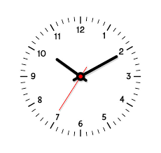

* What day is it? Yesterday, today, tomorrow?
* Use sand timers, phones, clocks all to measure short periods of time
* Countdowns 10/20 seconds to get to the table/to bed etc
* Recognising numbers on a clock