**Welcome to your Autumn Term Homework.**

This term we are learning about the Roman Empire including the role of Roman soldiers, the successful conquest of Britain and the impact that they had upon us right up to the present day.

We hope you enjoy the tasks and we look forward to sharing completed work in school. As a guide, you should be completing two tasks per half term. As we are limited in what we can share in class, you could email photos or videos to: [Year4@billingshurstpirmary.org.uk](mailto:Year4@billingshurstpirmary.org.uk)

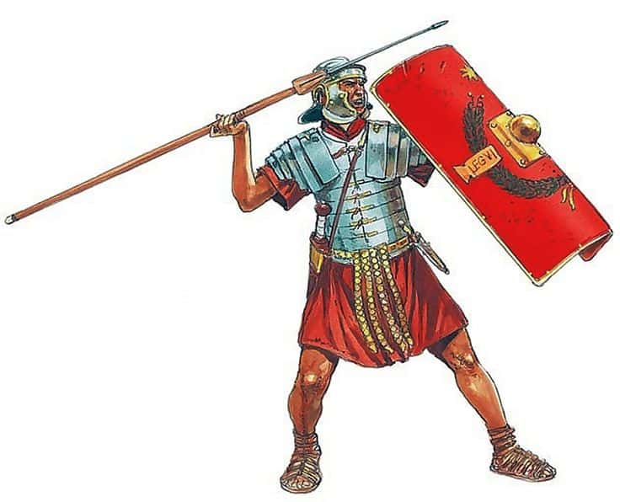

**Roman Numerals**Show us what you have learnt about Roman numerals in a fun, creative way of your choice. You may make a monthly calendar or solve some calculations using Roman numerals.

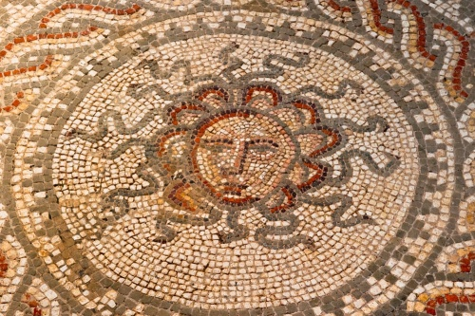

**Design**Can you design and create your own Roman shield? Think about the materials if might need to be made of to survive in battle and the type of Roman design you might want to include on it.

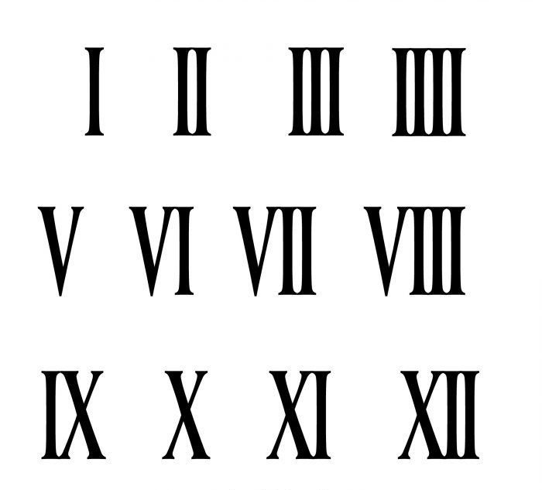

**Roman Soldiers**

Find an image of a Roman soldier, or even better, draw your own. Label the main parts of their uniform and equipment and explain how each item was used. To develop this further, compare and contrast a Roman soldier with a British soldier in the present day.

**Roman Mosaic**

The floors of Roman buildings were often decorated with mosaics. Make a design that could be used and use coloured paper or colouring pencils to create it.

**Worth a visit…..**

Pay a visit to the largest Roman home in Britain at Fishbourne Roman Palace and Gardens, West Sussex.

Or, pop along to Bignor Roman villa and learn about the Tupper family who discovered it and still live there today.

**Fit and Healthy**Soldiers now and then need to maintain a good level of fitness. Design your own circuit of activities that you could practise regularly. You could include skipping, sprinting, jumping, throwing etc.

**Roman Geography**

Londinium was the Roman name for our capital city, London. Verulamium, Lindum and Eboracum were the Roman names given to other cities in the UK. Can you find out where these places are or research other Roman names before placing them on a map of the UK?

**Roman Food**

A staple part of the Roman diet was bread. What basic bread recipes can you find and make at home? Can you write a set of instructions to go with your bread?

**Creative Writing**

Imagine yourself as a Roman soldier and write about your experiences in the form of a diary, a letter or an interview.