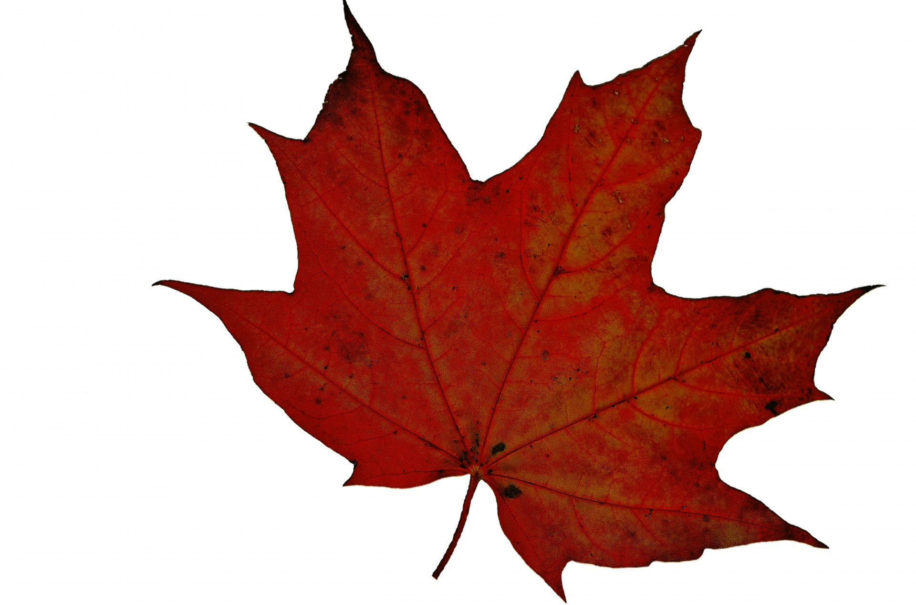

**Welcome to your Autumn Term Homework.**

This term, we are learning about how we are super and for Autumn 1’s homework, we want to find out about you! We hope you enjoy these opportunities and look forward to sharing what you have been learning at home. We will share your learning in class, and you could also email photos to: [Year1@billingshurstprimary.org.uk](mailto:Year1@billingshurstprimary.org.uk) so that we can then share them on the big screen with the other children. We will share these in class as soon as we have time, but this may not be the same day. Have a go, try you best and have fun! Happy homework!



**Writing**

**Write to us to tell something interesting about you.**

Do you have a special talent? What is your favourite food?

What are you good at?

Is there something you want to get better at? You might want to draw a picture as well.

**Maths**

**How many legs in your house?**

Can you work out how many legs are in your house? This could include pets, furniture or anything! You could use pictures, words and numbers to represent this.

**Reading**

**My Favourite book is…**

Tell us about your favourite book. Why do you like it? Who wrote it?

Has the author written other books?

Do you have a favourite part?

**History**

**What were you like when you were a baby?**

Spend time looking at your baby photographs. What did you look like? What could you do? What couldn’t you do? How have you changed? You could make a poster to answer these questions.

**Geography and Science**

**What season are we entering?**

The weather is changing. The trees and plants are starting to look different. What season are we entering? How do you know? What can you see and hear? You might want to collect items from outside and make a college or draw a picture and add labels to explain what season we are in.

**Health and Self-care**

**What is healthy?**

What do you know about healthy eating? Create a plate of food that you could serve as a healthy meal. You could create a collage of pictures, make the food to go on your plate or draw your healthy meal.

You could share this in a photo.