# Understanding Grip Development ….

**Palmar Supinate Grip** – 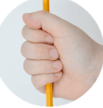

Most children start mark making by using the palmar grip. The implement is held in the palm of the hand and the fingers curl around it to hold it in place. The movement is mainly controlled through the shoulder and elbow joints (gross motor) and children will typically make vertical, horizontal and round marks.

**Digital Pronate Grasp** –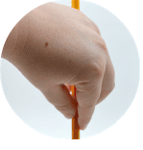

The next grip is often the digital pronate grasp, although not all children use this. The mark making implement is controlled by one digit, usually the index finger, and held in place by the thumb. To use this grasp, the child needs to pivot from the wrist to get to the paper. Movement is limited and mark making is similar to that of the palm grip

**Static Tripod Grip -** 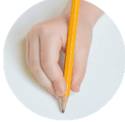

The next stage is often the static tripod grip which is commonly favoured by boys. The pencil is pushed right to the end of the fingers. The movement is controlled by the little finger and clamped in place by the thumb although all the digits are in contact with the pencil. With this grip it is difficult for the child to see the marks they are making which hinders correct letter

**Triangulation Grip -** 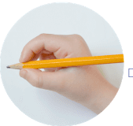

The triangulation grip is where the pencil is held between the forefinger and the thumb and supported from behind by the middle finger. Ideally, only these three digits control the movement of the pencil. The movement (fine motor) is controlled by the joints of the fingers and thumb and allows for maximum range of movement and flexibility. This is the grip to aim for.

# Billingshurst Primary Academy https://www.billingshurstprimary.org.uk/core/passwords/read_logo/16b1bd93695f0c940ede52343c0558da

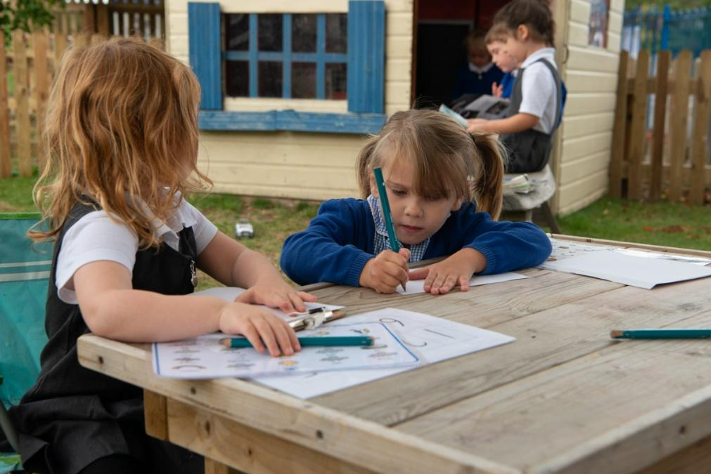

## Supporting your child with Writing

## Information for parents and carers.

# The Writing Journey

As adults we take being able to write for granted but for children, writing is a skill that they have to learn it is skill they have to be taught. Like so much during childhood it develops gradually.

## Starting to write…

Children begin their journey towards writing by making marks, not by producing letters and words.

The first clear sign that children are interested in mark making comes when they use thick crayons to make big circular and straight lines. This type of mark-making is often dismissed as scribble, but it is actually an important step in learning to write, because children are trying out new things to see what happens.

## Mark Making …

The marks children make slowly begin to have more meaning for them, and you will be able to see this by listening to what they say when they play with pens, crayons and paper.

At first, mark making is a mix of writing and drawing and most begin to understand the drawing and most begin to understand the difference between drawing and writing sometime after their third birthday. They may act out ‘writing’ situations; especially if they have seen other people do them. This means that

many children left with a pen and the shopping list may want to add items to that list. This can be a nuisance, especially if the children’s marks cover the original list, but it shows how much they value adult writing. 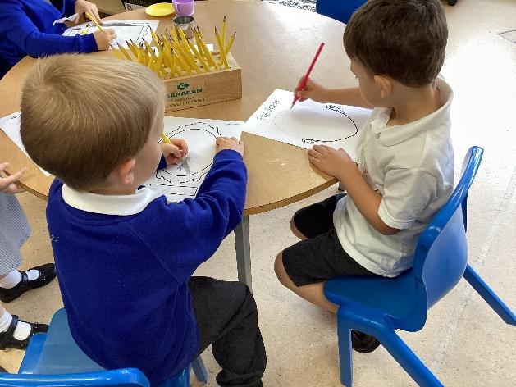

## From First Words to Confident Writing …

At around four years old, children begin to write their first words; and their own name is usually the first of all. This is partly because it has huge meaning for them and also because adults tend to point out and write children’s names. At first, we may simply notice that their mark making contains a few more letters. Then they learn to write their name. This is a spectacular breakthrough in the writing journey.

The next stage of writing depends on children’s knowledge of reading. Hence why this is also an important skill. As children learn about reading, letter shapes and words begin to have more meaning for them. This is when adults need patience. Learning to read takes time and, while some children crack the code earlier than others, most do not really learn to read well until they are six years old.

When children are learning to read, they often start to write quite simple and repetitive sentences because they are confident about how to put these down. Try not to ‘correct’ children about what they write at this time, as this can stop them from having a go at writing new words. At school we encourage children to listen for the sounds that they can hear in the words they want to write.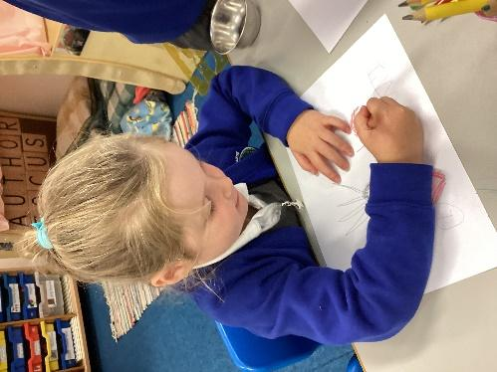

If for example they want to write “I love my mummy” and they can hear the following “I lv mm”. We praise the children for this and allow them to write this, as they become more experienced readers and writers they will be able to hear more sounds in the words that they want to write. If however we simply told the child or wrote it down for them to copy we are discouraging them to think for themselves and having a go at writing.

By about the age of seven or eight children’s moves to a different stage, in which they know what they want to write and are able to write it quite well.

# Handwriting …

Handwriting is not the same as writing. It is important to understand the difference between handwriting and writing. Handwriting is about putting words down on paper, while writing is the ‘thinking’ of the actual words.

For children, learning to control a pencil, pen or even paintbrush is hard. To do it, they first need to develop their hand–eye coordination, and build up the muscles and control in their hands. And children need more than just the control of their hands – they also need to be able to coordinate their arms and shoulders. Controlling these larger movements is what comes first.

So while children may enjoy mark-making, we must be careful not to force them into writing before they are ready as they will find it easier if they have had the chance to work on controlling their whole arm movements. This is one of the many reasons why the Early Years Curriculum (followed during the reception year) is a play-based curriculum encouraging children to be active in their learning.

This will also help them to develop a better handwriting style later on. These larger movements are usually made by children quite naturally as they play outdoors, by throwing balls or using their arms to help them climb up a slide. When they run, jump, climb, twist and twirl, young children are actually building the muscles they need for good handwriting later on.

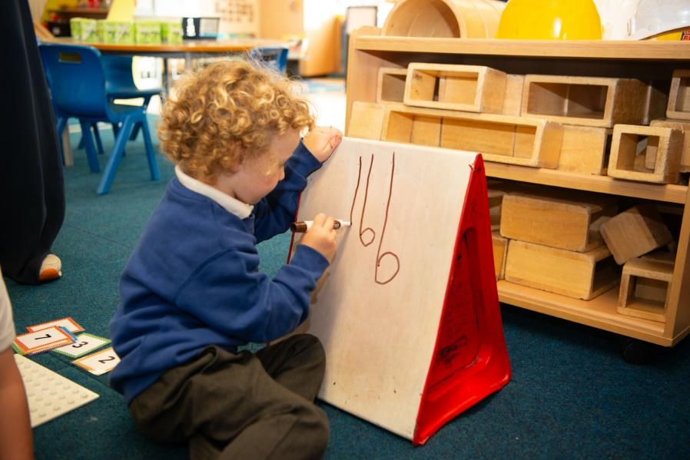

# TOP TIPS

Be ready to join in the drawing and painting.

Look out for washable paints and felt tips.

Show children how you write.

Write notes and letters to your child.

Avoid ‘teaching’ and ‘correcting’ children.

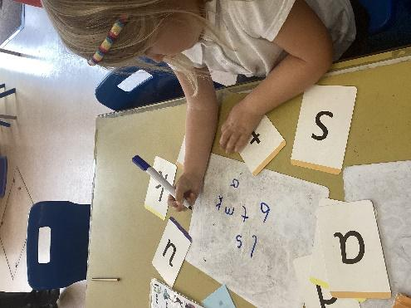

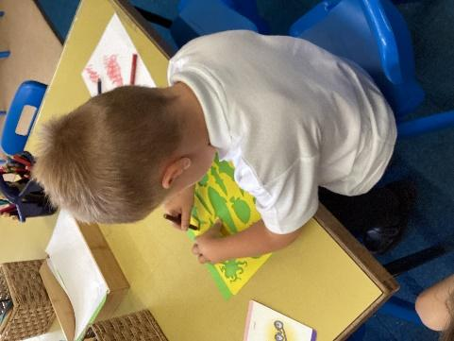

# How to help your child learn …

## Helping children’s writing …

First of all, it is helpful if parents and carers understand that learning to write takes a few years.

## Try to see things from their point of view.

Understanding how children see the world will help you to help them as they learn.

## Let children be children.

A skilled five year old grows from a busy four year old, a curious three year old, a cuddled two year old, an adventurous one year old and a communicative baby.

## Be a playful companion.

You can enjoy childhood with the children as well.

## Feelings matter

Both the children’s emotions and your own are part of any situation with young children. It is very helpful to be aware of your own moods as well as the children’s when enjoying yourself with them and during difficult moments.

## Don’t expect to be perfect.

Everyone does something they don’t mean sometimes. Children can be forgiving as long as we are thoughtful most of the time and are ready

## Helping children's Handwriting …

Children develop the hand skills needed to hold and control a pencil as they make everyday movements around the house rather than with paper and a pen.

• Folding clothes,

• Wiping up spills and learning to dry up cups

• Putting on coats and doing up shoes

• Pouring out drinks and cooking

## As well as everyday skills, children may also enjoy playing games that need hand skills, such as:

• ‘Kerplunk’ or ‘Pick up sticks’

• Jigsaws

• Building bricks

• Threading chunky beads onto laces

## To help children develop the skills that will help their handwriting later on:

• Encourage them to help around the home with odd jobs

• Take time to show them how to manage buttons and zips, and to put on clothes

• Play throwing and catching games together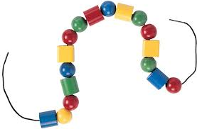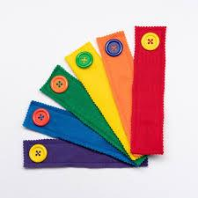

# Some Common Worries …

Because writing is such an important skill, it is normal that parents have the odd worry about it. Here are some of the worries parents often have:

## Pencil Grip:

Children who are developing strange pencil grips do so because they are desperately looking for a way to control their movements. The grip used by young children will usually improve as their hand movements become more controlled, so long as they are not put under pressure to gain control by doing a lot of tracing or being expected to produce small writing.

## Back to front letters:

Children have to rely on their memory to write letters until they become good readers. This means that nearly all children will reverse their letters early on, or miss letters out of words.

## Left-handed children:

Children are born being either right-handed or left-handed and this normally shows by about three years. Left-handed children find it easier if they are writing on a slope and benefit from having opportunities to do large scale mark-making. When using paper move the paper over to the left hand side so they can keep their arm and hand straight.

## Spelling:

This usually becomes more accurate as children learn to read. It is worth taking a relaxed approach because, if children become anxious about how to write down a word, they may develop a habit of only writing what they know they can spell. This leads to children writing less and, in the end, they become less imaginative writers. Even so, once children begin to read it is worth pointing out words that ‘play tricks’ on us in the way they are spelt words like ‘phantom’, ‘knight’ or ‘would’. Doing this can help children remember the words later on.

## Children who are not interested:

Mark-making must be fun for children. Try putting out ‘real’ pens and paper or taking out a bucket of water and a paintbrush for children to enjoy playing with them. Try hard not to pass comments about how young children’s writing looks, as this can put some children off. And remember that children need to see the adults around them writing.

The Ideas above have been taken from Making their mark – children’s early writing by Penny Tassoni.