Term | Autumn |  | Spring |  | Summer
Topic /Theme | People are amazing |  | Our wonderful World |  | Magical Beasts
Learning experiences | How do I? - class exploration  Transition - settling in and making friends  All about me - sharing family photos  All about my family - family photos  People who help us - visitors from the community  Amazing communities - local visitors |  | Under the sea  Environment protection - eco warriers  Growing - planting our own gardens  Seasons - nature walks around school  Habitats  Weather  Animals and people  Maps - treasure maps and world maps |  | Farms - local farm visit  Comparing habitats  Wild animals - going on safari, through role play  Animal patterns - art projects  Made up creatures  Dreams
Core Texts to support topic/theme  Possible drawing club books | 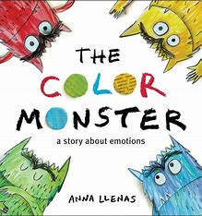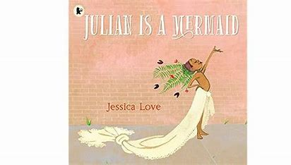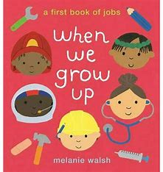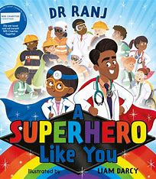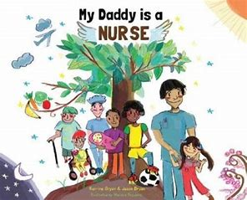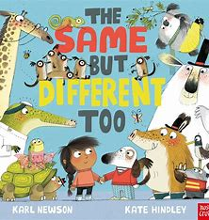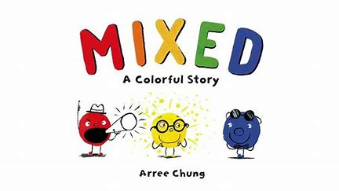 |  | 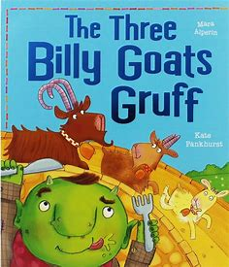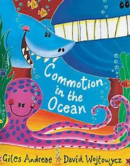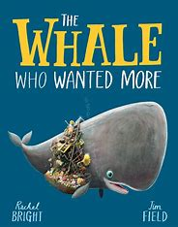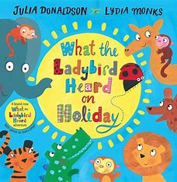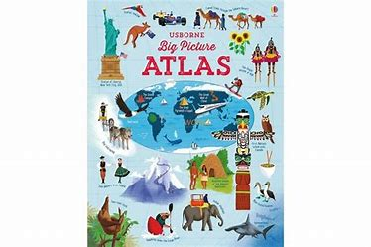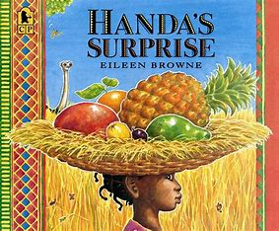 |  | 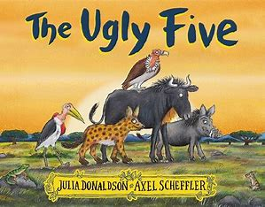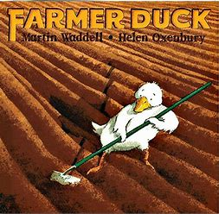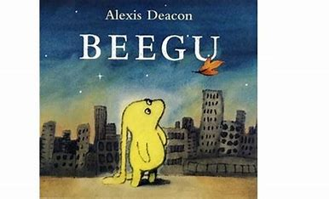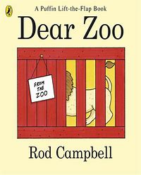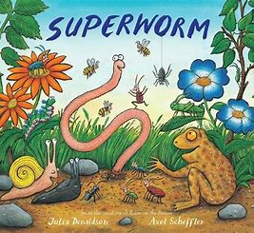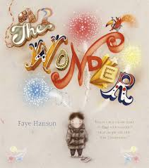
Literacy  Word Reading  Writing  Comprehension | Autumn 1 – writing Opportunities  Drawing club – code writing and mark making  - Mark making opportunities, large and small scale.  - Funky finger activities - developing fine motor skills (every morning)  - Writing names  - Dominant hand, tripod grip, mark making, giving meaning to marks and labelling.  - Mark Making & Writing initial sounds  - Letter patterns  Reading Opportunities  - RWI Set 1 whole class.  - Initial sounds  - Oral blending  - Reciting known stories  - Listening to stories with attention and recall  - Help children to read the sounds speedily.  - Ensure books are consistent with their developing phonic knowledge  - Understand that print has meaning; print can have different purposes.  Comprehension Opportunities  - Talking about their favourite stories/rhymes  - Joining in with extended conversations about books. |  | Spring 1 - Writing Opportunities  Drawing Club - code writing, 2 or 3 word captions  - Writing some of the tricky words such as I, me, my, like, to, the.  - Writing CVC words.  - Labels using CVC, CVCC, CCVC words  - writing for different purposes, such as information writing, labelling diagrams.  - Start to form capital letters and lower case letters correctly.  Reading Opportunities  - Phonic Sounds: RWI Differentiated groups.  - Re-read books to build up confidence in word reading, fluency and understanding and enjoyment.  - Engages with books and other reading materials at an increasingly deeper level  - Spell words with correct initial and some correct medial sounds  Comprehension Opportunities  - Making up stories  - Encourage children to record stories through picture drawing/mark making.  - Using recently introduced vocabulary during discussions about stories and during role-play |  | Summer 1 - Writing Opportunities  Drawing Club – children take part independently (where appropriate)  - Writing for a purpose in role play using phonetically plausible attempts at words.  - Beginning to use finger spaces.  - Beginning to think about where and how to form Capital letters.  - Write simple sentences independently.  Reading Opportunities  - Phonic Sounds: RWI Differentiated groups.  - Non-fiction texts.  - Internal blending  - Say a sound for each letter in the alphabet and at least 10 digraphs  - Naming letters of the alphabet  Comprehension Opportunities  - Can explain the main events of a story.  - Can draw pictures of characters/events/settings in a story.  - May include labels, sentences or captions.  - Retell a story with actions and / or picture prompts as part of a group.  - Use story language when acting out a narrative.
 | Autumn 2 – writing Opportunities  Drawing club – code writing and mark making  - Name writing – names nearly formed correctly.  - Writing some letters correctly  - Practising correct letter formation  - Labelling using initial letter sounds  - Starting to explore writing for pleasure  - Retelling stories in writing areas, using vocabulary and picture clues  Reading Opportunities  - Blending CVC sounds, rhyming, alliteration, knows that print is read from left to right.  - Spotting diagraphs in words.  - Read a few common exception words matched to the school’s phonic programme.  Comprehension Opportunities  - Sequence story – use vocabulary of beginning, middle and end.  - Enjoys an increasing range of books.  - Retell stories related to events through acting/role play/using pictures and prompts |  | Spring 2 - Writing Opportunities  Drawing Club – Code writing words, and simple sentences  - Writing shorts sentences  - Labels and captions.  - Write a sentence. Ensuring correct letter formation.  Reading Opportunities  - Phonic Sounds: RWI Differentiated groups.  - Story structure-beginning, middle, end. Innovating.  - Retelling stories to an audience.  - Looking at non-fiction books.  Comprehension Opportunities  - Re-read books to build up their confidence in word reading, their fluency and their understanding and enjoyment.  - Uses vocabulary and forms of speech that are increasingly influenced by their experiences of books.  - They develop their own narratives and explanations by connecting ideas or events |  | Summer 2 - Writing Opportunities  Drawing Club – writing code sentences, in some cases writing more than 1 code sentence  - Write recognisable letters, most of which are correctly formed.  - Spell words by identifying sounds in them and representing the sounds with a letter or letters.  - Write simple phrases and sentences that can be read by others.  Reading Opportunities  - Phonic Sounds: RWI Differentiated groups.  - Say a sound for each letter in the alphabet and at least 10 digraphs.  - Read words consistent with their phonic knowledge by sound-blending.  - Read aloud simple sentences and books that are consistent with their phonic knowledge, including some common exception words  Comprehension Opportunities  - Can draw pictures of characters/ events / settings in a story.  - Listen to stories, accurately anticipating key events & respond to what they hear with relevant comments, questions and reactions.  - Make predictions.  - Fiction and Non- Fiction: Beginning to understand that a non-fiction is a nonstory- it gives information instead. Fiction means story.
Maths  Number  Numerical Pattern | Autumn 1  Number  We follow NCTEM scheme for our maths lessons  - number rhymes  - spotting numbers in our environments  - Matching amounts, and talking about what they notice.  - Subitise to 3  - sequencing numbers  Numerical Pattern  - Explore patterns and shape  - look at how things will move about  - start to use positional language  - compare length and height |  | Spring 1  Number  We follow NCTEM scheme for our maths lessons  - Count objects, actions and sounds (subitising) up to 8.  - Compare numbers up to 5 and then up to 8.  - Explore the composition of numbers up to 8. Including recapping number bonds to 5 then up to 8.  - Number hunts  - Matching groups to their numerals  - Part part whole of numbers  Numerical Pattern  - Compare capacity  - Use of positional language  - Missing number patterns |  | Summer 1  Number  We follow NCTEM scheme for our maths lessons  - Introduce add/subtract/equal signs  - Recognise and recall number bonds beyond up to 10.  - Explore odd numbers and then even  - Developing the understanding of double  - looking at teen and ty numbers  Numerical Pattern  - sequencing events and groups (links to sports day)  - cardinal and ordinal numbers  - counting patterns, counting in 5s.
 | Autumn 2  Number  We follow NCTEM scheme for our maths lessons  - Looking at parts and wholes of objects/items and numbers  - Finding numerals in provision  - Count objects, actions and sounds (subitising) up to 5.  - Compare numbers up to 5.  - Explore the composition of numbers to 5 (bonds).  Numerical Pattern  - Continue, copy and create repeating patterns  - Select, rotate and manipulate shapes to develop spatial reasoning skills  - Compare weight modelling |  | Spring 2  Number  We follow NCTEM scheme for our maths lessons  - Looking at addition and subtraction  - Solving number problems  - Explore number bonds to 10  - Count objects, actions and sounds (subitising) up to 10  Numerical Pattern  - Looking at odds and evens  - Looking at doubles and halves  - Sharing |  | Summer 2  Number  We follow NCTEM scheme for our maths lessons  Numerical Pattern
Communication and Language  Listening, attention and understanding  Speaking | Autumn 1  - Settling in activities and carpet times. Nursery rhymes.  - The Colour Monster – moods and feelings.  - Adults modelling language throughout the day “Thank you!” “Good morning!” “How are you?” “Please could you pass me…?”  - Sound assessment Baseline |  | Spring 1  - Listen to stories to build familiarity, understanding and increase vocabulary.  - Ability to speak in sentences using language to develop relationships.  - Retelling a story using story language.  - Asking how and why questions… Sharing Christmas holiday news  - Holding conversation in back and forth exchanges with adults and peers. |  | Summer 1  - Retelling stories with an increased knowledge of story language and vocabulary.  - Relate the stories they have listened to in their lives and their role-play.  - Make up their own stories with beginning, middle and end.
 | Autumn 2  - Links to festivals, children's experiences, talking about shared experiences.  - Songs – Nativity and Christmas songs.  - Listening to stories and developing vocabulary.  - Use new vocabulary through the day  - Good listening skills.  - School start interventions  - Individual speech assessments. |  | Spring 2  - Sustained focus when listening to a story.  - Describing events in detail using connectives.  - Understanding and using question words such as what, where, who… Sharing weekend news.  - Holding conversation in back and forth exchanges with adults and peers. |  | Summer 2  - Listen attentively and respond to what they hear with relevant questions, comments and actions when being read to and during whole class discussions and small group interactions.  - Make comments about what they have heard and ask questions to clarify their understanding.  - Participate in small group, class and one-to-one discussions, offering their own ideas, using recently introduced vocabulary.  - Offer explanations for why things might happen, making use of recently introduced vocabulary from stories, non-fiction, rhymes and poems when appropriate.  - Sharing experiences from their lives using full sentences including use of past, present and future tenses
 | Communication is developed throughout the year through high quality discussion, and speaking and listening activities. These might be within the everyday provision, or talk partners, small group conversations, circle times. Communication and Language underpins everything we do in Early Years.
 | Autumn 1 - 2 |  | Spring 1 - 2 |  | Summer 1
Personal, Social and Emotional Development  Self Regulations  Managing Self  Building relationships | Self regulation - Throughout the year children will work towards simple goals, being able to wait for what they want and control their immediate impulses when appropriate. Give focused attention to what the teacher says, responding appropriately even when engaged in activity, and show an ability to follow instructions involving several ideas or actions.  * Controlling own feelings and behaviour. * Able to concentrate on a task * Applying personalised strategies to return to a state of calm. * Able to ignore distractions. * Thinking before acting. * Able to curb impulsive behaviour. * Behaving in ways that are socially acceptable. * The ability to persist and persevere
Summer 2 - Self Regulation
- Show an understanding of their own feelings and those of others, and begin to regulate their behaviour accordingly.
- Set and work towards simple goals, being able to wait for what they want and control their immediate impulses when appropriate.
- Give focused attention to what the teacher says, responding appropriately even when engaged in activity, and show an ability to follow instructions involving several ideas or actions
 | Autumn 1  Managing Self -  - New Beginnings.  - See themselves as a valuable individual.  - Being me in my world.  - Class Rule Rules and Routines.  - Supporting children to build relationships. |  | Spring 1  Managing Self -  - Feelings. Identify and moderate their own feelings socially and emotionally.  - Learning about qualities and differences.  - Celebrating differences  - Encourage them to think about their own feelings and those of others by giving explicit examples of how others might feel in particular scenarios |  | Summer 1  Managing Self -  - Looking after others.  - Friendships.  - Show resilience and perseverance in the face of challenge.  - Discuss why we take turns, wait politely, tidy up after ourselves and so on.
 | Autumn 2  Managing Self -  - Getting on and falling out.  - How to deal with anger  - Self - Confidence  - Build constructive and respectful relationships.  - Ask children to explain to others how they thought about a problem or an emotion and how they dealt with it |  | Spring 2  Managing Self -  - Relationships. What makes a good friend?  - Healthy me.  - Random acts of Kindness.  - Looking After our Planet.  - Give children strategies for staying calm in the face of frustration. Regulation techniques  - Talk them through why we take turns, wait politely, tidy up after ourselves and so on. |  | Summer 2  Managing Self -  - Taking part in sports day.  - Winning and losing  - Be confident to try new activities and show independence, resilience and perseverance in the face of challenge.  - Explain the reasons for rules, know right from wrong and try to behave accordingly.  - Manage their own basic hygiene and personal needs, including dressing, going to the toilet and understanding the importance of healthy food choices.
 | Building relationships - Throughout the year, children will work towards forming relationships with the adults and their peers. They will begin to understand how relationships are formed and show an ability to show sensitivity to other’s needs. Playing both team games and board games play an important role in the Reception year.
Summer 2 - Building Relationships -
- Work and play cooperatively and take turns with others.
- Form positive attachments to adults and friendships with peers.
- Show sensitivity to their own and to others’ needs.
Physical development  Fine Motor  Gross Motor | Autumn 1  Fine Motor -  - Funky finger activities (daily) - name writing, threading, weaving, playdough, tweezers, cutting skills.  - Show preference for dominant hand.  - Draw lines and circles using gross motor movements.  - Hold pencil/paintbrush beyond whole hand grasp.  - Pencil Grip – encourage tripod grip  Gross Motor -  - Cooperation games i.e. parachute games.  - Climbing on outdoor equipment.  - Different ways of moving to be explored with children.  - Help individual children to develop good personal hygiene.  - Provide regular reminders about thorough handwashing and toileting. |  | Spring 1  Fine Motor -  - Daily funky finger activities  - Begin to form letters correctly.  - Handle tools, objects, construction and malleable materials with increasing control.  - Encourage children to draw freely.  - Holding Small Items / Button Clothing / Cutting with Scissors.  Gross Motor -  - Ball Skills- aiming, dribbling, pushing, throwing & catching, patting, or kicking.  - Provide a wide range of activities to support a broad range of abilities.  - Dance / moving to music. Gymnastics/ Balance. |  | Summer 1  Fine Motor -  - Daily Funky Finger activities  - Develop pencil grip and letter formation continually  - Use one hand consistently for fine motor tasks.  Gross Motor -  - Obstacle activities children moving over, under, through and around equipment.  - Encourage children to be highly active and get out of breath several times every day  - Team games practise
 | Autumn 2  Fine Motor -  - Develop muscle tone to put pencil pressure on paper.  - Daily funky finger activities  - Use tools to effect changes to materials.  - Show preference for dominant hand  - Teach and model correct letter formation.  Gross Motor -  - Ball Skills-throwing and catching  - large building, and obstacle courses outside, thinking about travelling over, under and through.  - Use their core muscle strength to achieve a good posture when sitting at a table or sitting on the floor. |  | Spring 2  Fine Motor -  - Daily Funky Finger activities  - Hold pencil effectively with comfortable grip Forms Recognisable letters most correctly formed.  Gross Motor -  - Balance- children moving with confidence  - Playground games - focus on coordination, and spacing (grandmother's footsteps, whats the time mr wolf, duck duck goose) |  | Summer 2  Fine Motor -  - Daily Funky FInger activities  - Holding a pencil effectively in preparation for fluid writing using the tripod grip  - Hold a pencil effectively in preparation for fluent writing – using the tripod grip in almost all cases.  - Use a range of small tools, including scissors, paint brushes and cutlery. Begin to show accuracy and care when drawing.  Gross Motor -  - Races/team games involving gross motor movements (linked to Sports Day)  - Negotiate space and obstacles safely, with consideration for themselves and others. Demonstrate strength, balance and coordination when playing. Move energetically, such as running, jumping, dancing, hopping, skipping and climbing.
Expressive Arts  Creating with Materials  Being Imaginative and Expressive | Autumn 1  Creating With Materials -  - Self portraits  - Use of the continuous provision and how to use the resources and areas.  - Explore a variety of artistic effects, such as; painting, drawing, printing  - Safely use and explore a variety of materials, tools and techniques, experimenting with colour, design, texture, form and function  - Health yeating collages (All about me links)  Being Imaginative and Expressive -  - Introduces a storyline or narrative into their play  - Singing songs and learning some familiar songs & Rhymes. Role-play – home corner. Small world play |  | Spring 1  Creating With Materials -  - Chinese New Year - lanterns  - Valentines craft, heart chains  - cooking skills - making pancakes  - creating pictures using cutting and sticking skills - college  - exploring colour mixing  Being Imaginative and Expressive -  - Role play  - Small world  - using vocabulary from recent books in play  - Begins to build a collection of songs and dance |  | Summer 1  Creating With Materials -  - Animal prints - looking at different forms of printing and stamping  - Junk model making - combining materials to create a magical beast  - Using malleable materials such as clay and playdough to make an animal.  Being Imaginative and Expressive -  - Small world  - Role plays  - Using vocabulary from stories
 | Autumn 2  Creating With Materials -  - Listen to music and make their own dances in response.  - Explore a variety of artistic effects, such as; painting, drawing, printing  - Christmas decorations, Christmas cards, Divas.  Being Imaginative and Expressive -  - Introduces a storyline or narrative into their play  - Nativity Performance Role-play – home corner (enhanced with Christmas, christmas grottos, santa's workshops) |  | Spring 2  Creating With Materials -  - Thinking about how to join materials together using different skills  - Developing scissors skills - finging  - Thinking about how we can make things better  Being Imaginative and Expressive -  - Singing songs and learning some familiar songs – Easter songs.  - role play  - Small world |  | Summer 2  Creating With Materials -  - Farm pictures.  - Safely use and explore a variety of materials, tools and techniques, experimenting with colour, design, texture, form and function. Share their creations, explaining the process they have used. Make use of props and materials when role playing characters in narratives and stories.  Being Imaginative and Expressive -  - Invent, adapt and recount narratives and stories with peers and their teacher. Sing a range of well-known nursery rhymes and songs. Perform songs,rhymes, poems and stories with others, and – when appropriate – try to move in time with music.
Understanding the World  Past and Present  People, Culture and communities  The natural world | Autumn 1  Past and Present  - Who is in my family? Commenting on photos of their family – naming who they can see and of what relation they are to them.  - Can talk about what they do with their family and places they have been with their family.  - Name and describe people who are familiar to them.  People, culture and communities  - Describing their environment around them. Exploring what makes a family.  - The varying members of a family unit  The Natural World -  - Seasons – Autumn – differences and changes over time – weather, animals and plants |  | Spring 1  Past and Present  - Talk about how we celebrated different events through the holidays, what was the same, what was different?  People, culture and communities  - Recognise people have different beliefs and celebrate special times in different ways (Chinese New Year  The Natural World  - Draw information from a simple map, where we might find different animals  - Care and concern for living things.  - Care and concern for our planet |  | Summer 1  Past and Present  - Makes observations of animals and plants and explains why some things occur, and talks about change  People, culture and communities  - Recognise that other people have different beliefs  The Natural World  - Planting Sunflowers, beans and other flowers  - Looking at different habitats  - How to care for animals  - Understand the effects of changing seasons on the world around them
 | Autumn 2  Past and Present  - Links to festivals: Bonfire night, Diwali, Xmas  - Show photos of how Christmas used to be celebrated in the past.  People, culture and communities  - Roles of different jobs around us.  - What jobs do our family members do?  - Use world maps to show children where some stories are based.  - Use the Jolly Postman to draw information from a map and begin to understand why maps are so important  The Natural World  - Exploring light and dark.  - How can we see in the dark? Nocturnal animals – making sense of habitats. Which animals are nocturnal? |  | Spring 2  Past and Present  - Nature walks around school - looking at similarities and differences.  People, culture and communities  - Comparing different countries/places and communities  The Natural World  - What is growing in our garden? What would be the same and different around the world?  - Introduce the children to recycling and how it can take care of our world. Look at what rubbish can do to our environment and animals. Create opportunities to discuss how we care for the natural world around us. |  | Summer 2  Past and Present -  - Talk about the lives of the people around them and their roles in society. Know some similarities and differences between things in the past and now, drawing on their experiences and what has been read in class  People, culture and communities -  - Describe their immediate environment using knowledge from observation, discussion, stories, non- fiction texts and maps.  - Know some similarities and differences between different religious and cultural communities in this country, drawing on their experiences and what has been read in class.  - Explain some similarities and differences between life in this country and life in other countries, drawing on knowledge from stories, non-fiction texts and – when appropriate – maps.  The Natural World -  - Explore the natural world around them, making observations and drawing pictures of animals and plants.  - Know some similarities and differences between the natural world around them and contrasting environments, drawing on their experiences and what has been read in class.  - Understand some important processes and changes in the natural world around them, including the seasons and changing states of matter

