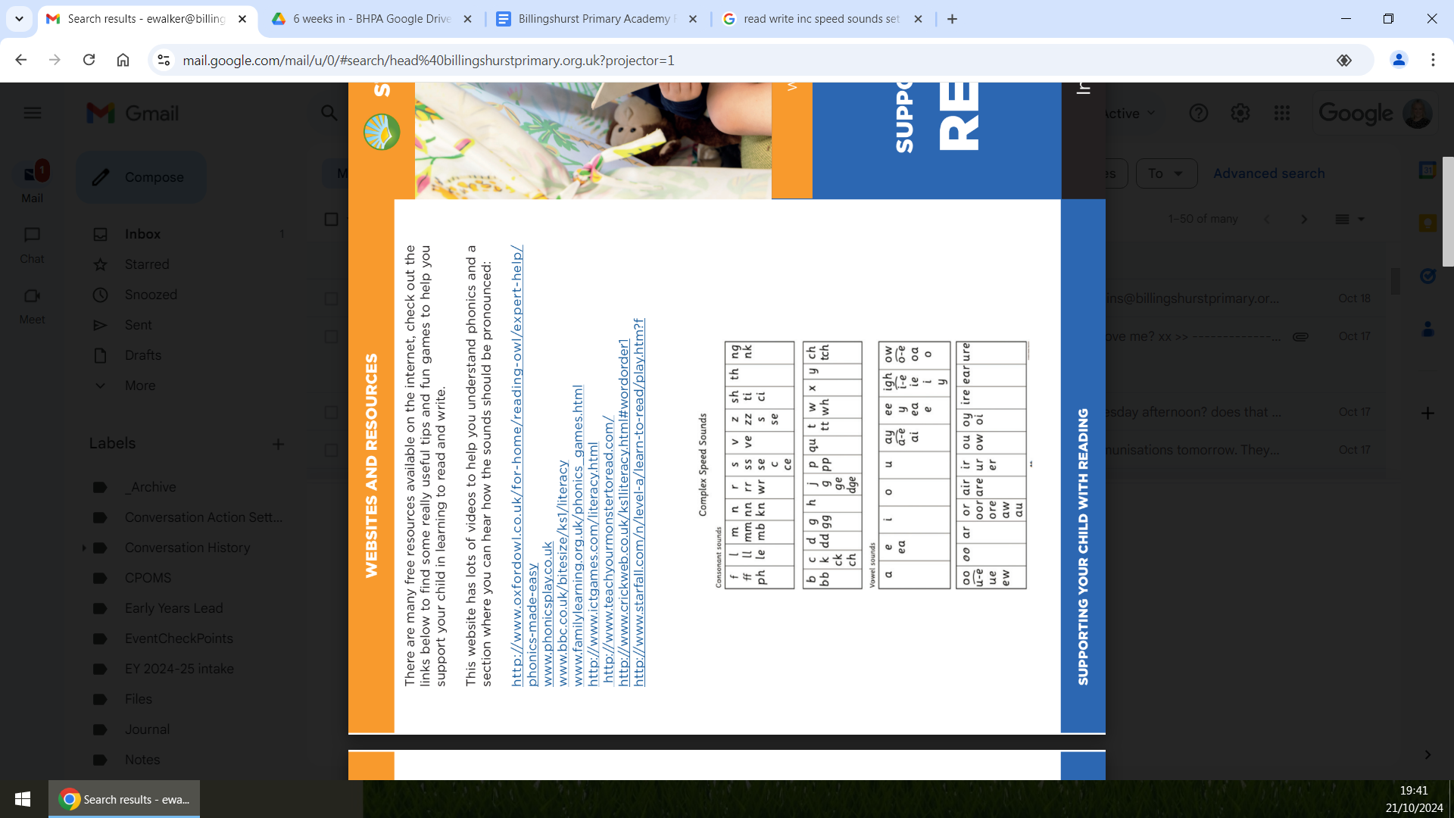

# Billingshurst Primary Academy https://www.billingshurstprimary.org.uk/core/passwords/read_logo/16b1bd93695f0c940ede52343c0558da

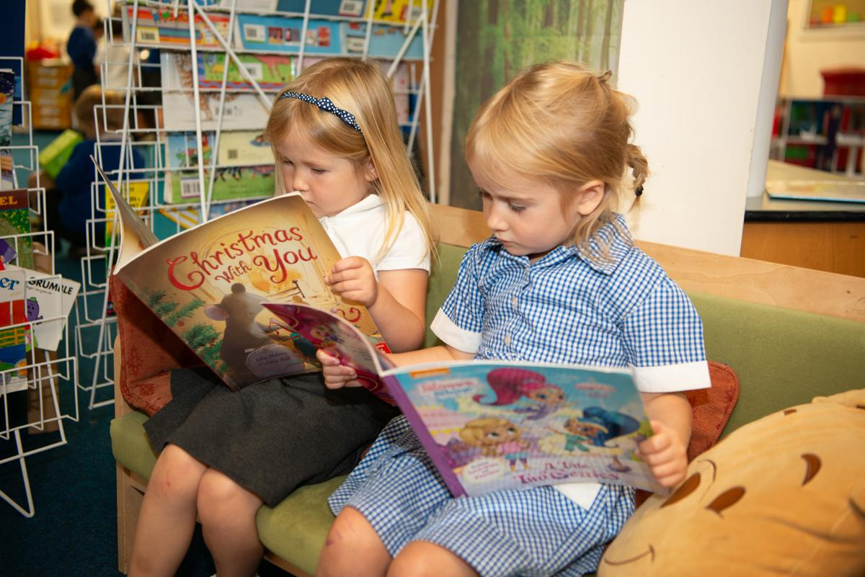

## Supporting your child with Reading

## Information for parents and carers.

# What is Phonics?

Phonics is the method of teaching reading which, at first teaches the letter sounds and then builds up to blending these sounds together so that they can read whole words. 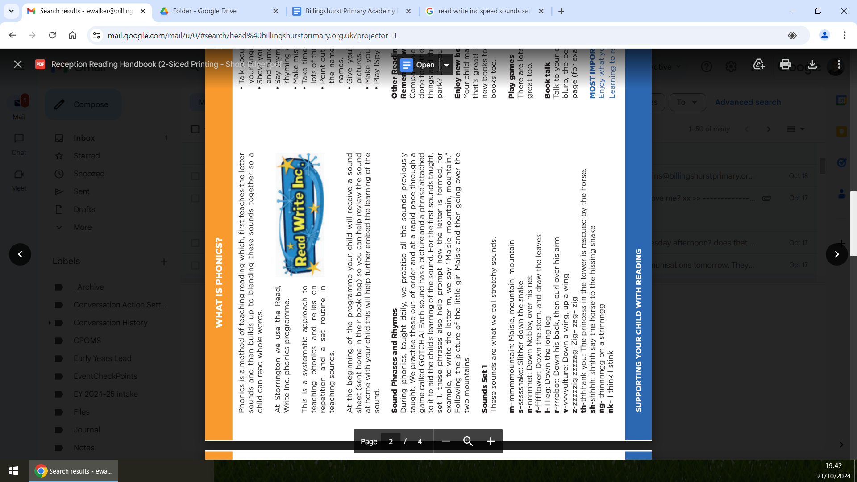

At Billingshurst Primary Academy we use the Read, Write Inc Phonics scheme.

This is a systematic approach to teaching phonics and relies on

repetition and a set routine in teaching

## Sound Phrases and Rhymes

During phonics, taught daily, we revise all the sounds previously taught. We practise these out of order and at a rapid pace. Each sound has a picture and a phrase attached to it to aid the child’s learning of the sound. For the first sounds taught, set 1, these phrases also help prompt how the letter is formed, for example, to write the letter m, we say “Maisie, mountain, mountain.” Following the picture of the little girl Maisie and then going over the two mountains.

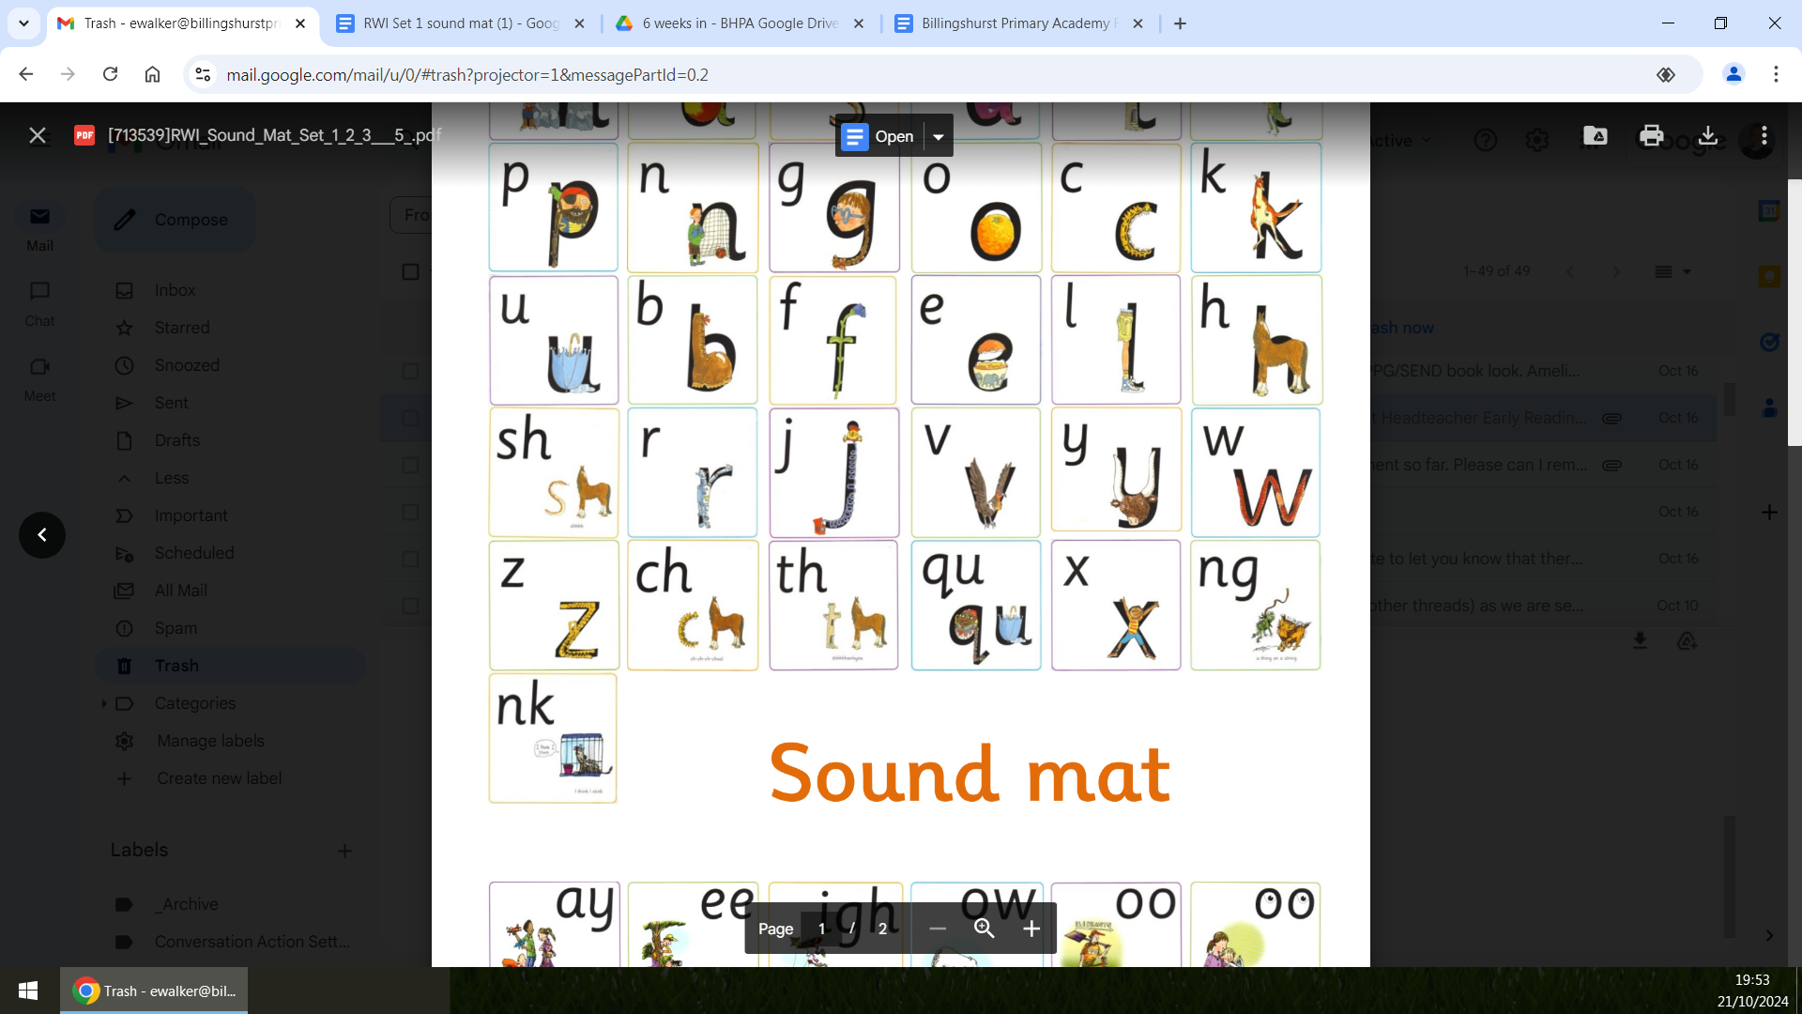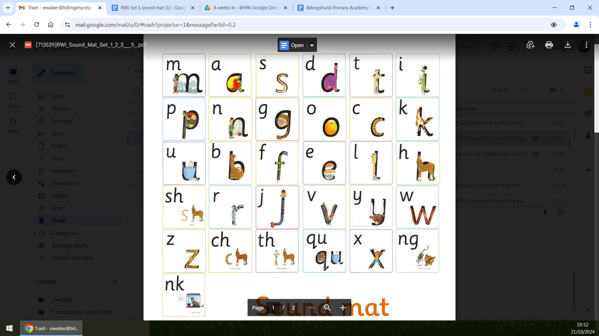

* Take your child to the library, let them choose exciting books with flaps, different textures, colourful pictures and sounds, and get them a library card.
* Let your child act out the story. They might be moving but they are still listening to you!
* Talk about reading from left to right and show your child, by using your finger, how to trace the words.
* Show your child how much you love reading and use expression and humour when reading to them.
* Say rhymes and sing songs together and let your child fill in the rhyming words at the end of the sentence.
* Make mistakes in familiar songs and rhymes... and get caught!
* Take time to listen to your child’s ideas and opinions - they have lots of them!
* Point out, and talk about, the words all around you, for example the name of the shop you are in, labels on food, familiar street names.
* Give your child their own short shopping list with words and pictures.
* Make your own picture books.

## Sounds Set 1

**These sounds are what we call stretchy sounds.**

m–mmmmountain: Maisie, mountain, mountain

s–sssssnake: Slither down the snake

n-nnnnnet: Down Nobby, over his net

f-ffffflower: Down the stem, and draw the leaves

l-llllleg: Down the long leg

r-rrrobot: Down his back, then curl over his arm

v-vvvvulture: Down a wing, up a wing

z-zzzzzig zzzzag: Zig– zag– zig

th-thhhank you: The princess in the tower is rescued by the horse.

sh-shhhh: shhhh say the horse to the hissing snake

ng- thinnnngg on a strinnngg

nk–I think I stink

**These next sounds are bouncy sounds. Make the sound as short as possible avoiding ‘uh’ at the end of the sound:**

t-t-t-t- tower: Down the tower, across the tower

p-p-p-p- pirate: Down the plait and over the pirate’s face

k-k-k-kangaroo: Down the kangaroo’s body, tail and leg

c-c-c-c-caterpillar: Curl around the caterpillar

h-h-h-h-horse: Down the head to the hooves and over his back

ch– ch-ch-ch-choo!: The horse sneezes when the caterpillar’s hairs get up his nose

x-x-x-x-exercise: Down the arm and leg and repeat the other side

qu-qu-qu-qu-queen: Round her head, up past her earring and down her hair

d–d-d-d-dinosaur: Round his bottom, up his tall neck, down to his feet

g–g-g-g-girl: Round her face, down her hair and give her a curl

b-b-b-b-boot: Down the laces to the heel and round the toe

j-j-j-jack-in-a-box: Down his body curl and dot

y-y-y-y-yak: Down a horn, up a horn and under his head

w-w-w-w-worm: Down, up, down, up

a-a-a-a-apple: Round the apple and down the leaf

e-e-e-e-egg: Lift off the top and scoop out the egg

i– i-i-i-insect: Down the body, dot for the head

o-o-o-o-orange: All around the orange

u-u-u-u-umbrella: Down and under, up to the top and draw the puddle

Once your child is secure in knowing all of the above letter sounds they will then move onto putting these sounds together (blending) to read words. At first they will be taught to read CVC words (consonant, vowel, consonant) words like cat, dog, bus, dig, mat, set etc. They will then move onto reading words with two letter sounds like ship, chip, sink, drink, sung etc.

Once your child is confident to read all of the above, and is no longer needing to decode words before blending them, and is able to read more complex words like sand,stick, splash, cress, etc. they will move onto learning set 2 sounds. For each child this journey will be different. When your child stats school they are assessed by their teacher to ascertain their starting point so they can be grouped for phonics according to their ability. Your child’s teacher will then continue to assess your child frequently

• **PRAISE** your child. The more confident they get, the more likely they are to make quicker progress.

# TOP TIP! Don’t force it!

Some children have a short attention span, and may only be interested for a few minutes before they want to do something else. If they don’t seem interested in a book, try something else, and come back to books another time. The last thing we want to do is turn a child off reading or learning all together. Your child won’t make progress if they are anxious or are put off reading. Talk to your child’s teacher if you have any concerns.

## Other top tips for reading with your child at home!

• Snuggle up and read with your child everyday. Have a special place to keep your books.

Story-time and book sharing gives families dedicated time that you spend with your child talking.

Your child has now started to bring home a reading scheme book, which they have read with their phonics teacher at school. The teacher will change this once a week on a set day (Friday). Please keep this scheme book in the book bag along with their reading record. Please read this book with them as much as possible during the week so they become really familiar with the text.

Learning books by heart is a really good skill and part of early reading. It is really helpful if you can also write a comment in the reading record so the teacher knows how your child is getting on at home with their reading.

## What should I do when reading with my child at home?

• Talk about the pictures in the book, and what they think the

characters might be doing and thinking and why.

• Read the book to them.

•Ask them to tell you the story, based on the pictures.This may not sound like reading, but it helps to develop language skills.

• Read a page, and then ask them to tell you what they think will happen next. You can also do this with any stories that you are reading to them. Again, this helps to develop language and storytelling skills.

• Ask your child to find you a letter sound that they recognise then find other examples of the same sound. You can also ask them to find a particular sound.

able to read more complex words like sand, stick, splash, cress, etc. they will move onto learning set 2 sounds. For each child this journey will be different. When your child starts school they are assessed by their teacher to ascertain their starting point so they can be grouped for phonics according to their ability. Your child’s teacher will then continue to assess your child frequently through reading and phonics sessions as well as phonics assessments so they will be taught set 2 and then set 3 as soon as they are ready.

It is important for your child to be a confident reader of words containing set 1 sounds before moving on to set 2 and 3.

**Speed Sounds Set 2**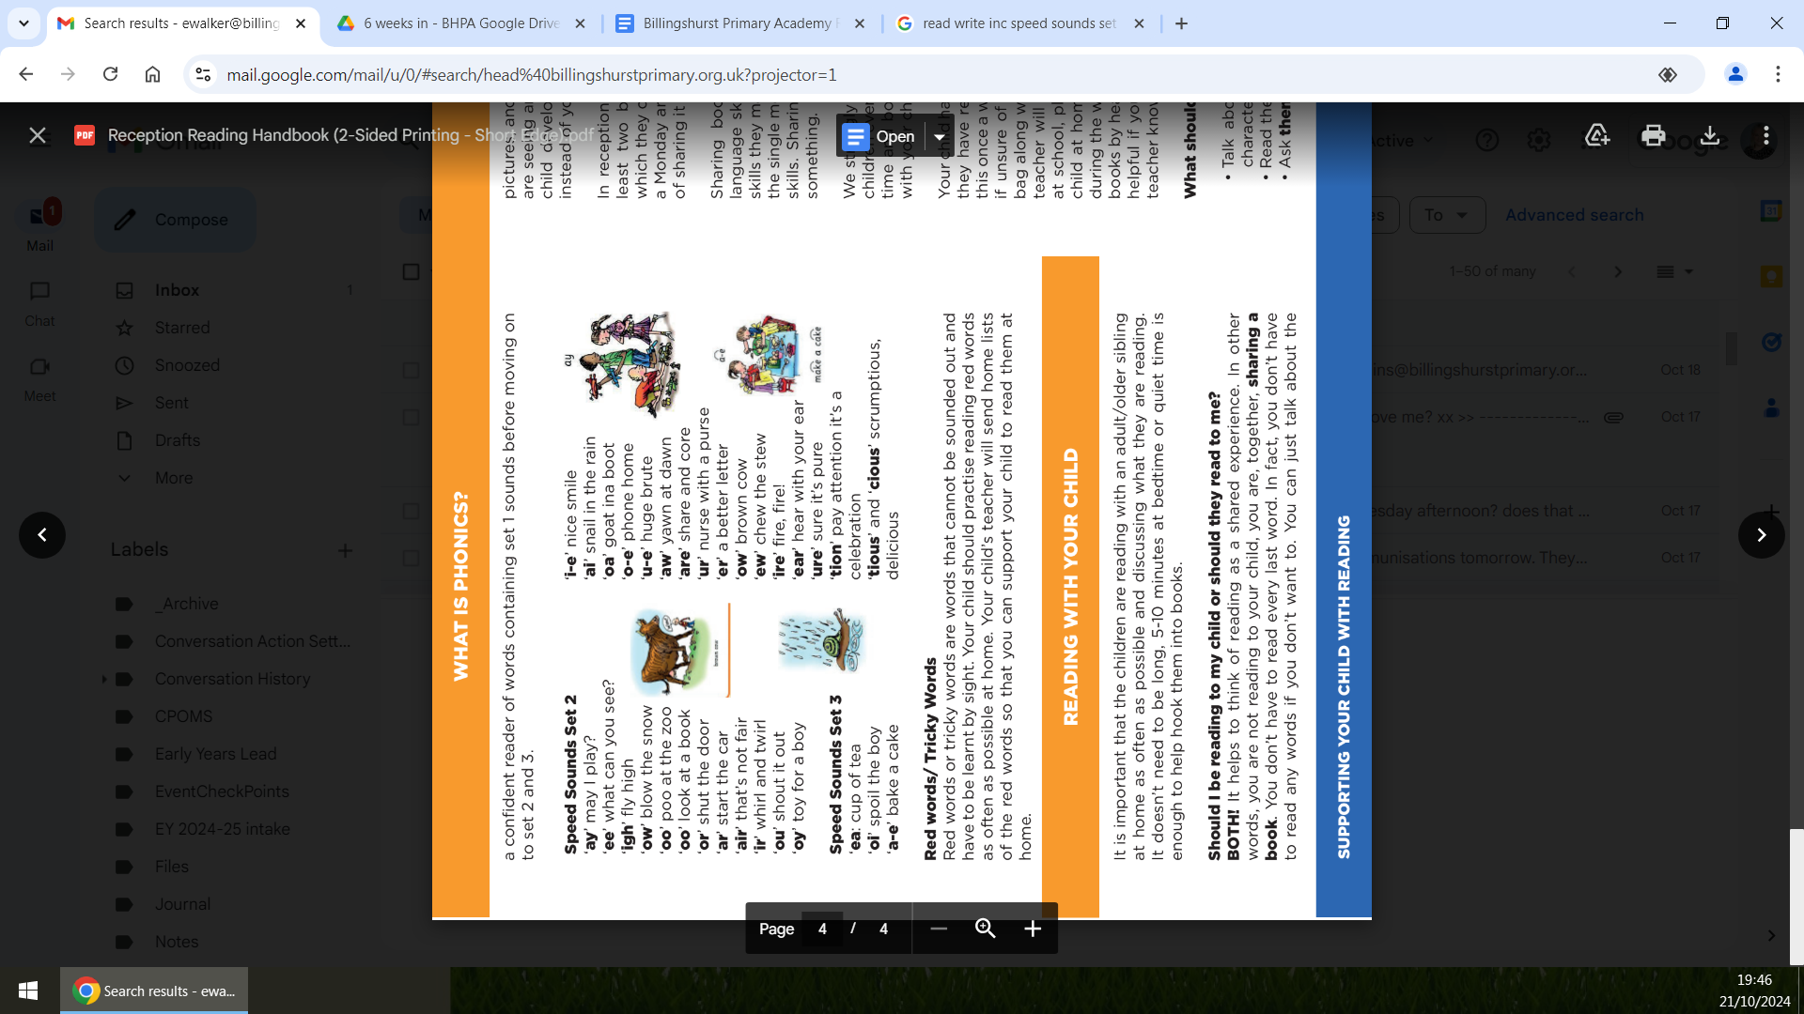

‘ay’ may I play?

‘ee’ what can you see?

‘igh’ fly high

‘ow’ blow the snow

‘oo’ poo at the zoo

‘oo’ look at a book

‘or’ shut the door

‘ar’ start the car

‘air’ that’s not fair

‘ir’ whirl and twirl

‘ou’ shout it out

‘oy’ toy for a boy

**Speed Sounds Set 3**

‘ea: cup of tea

‘oi’ spoil the boy

‘a-e’ bake a cake

‘i-e’ nice smile

‘ai’ snail in the rain

‘oa’ goat ina boot

‘o-e’ phone home

‘u-e’ huge brute

‘aw’ yawn at dawn

‘are’ share and core

‘ur’ nurse with a purse

‘er’ a better letter

‘ow’ brown cow

‘ew’ chew the stew

‘ire’ fire, fire!

‘ear’ hear with your ear

‘ure’ sure it’s pure

‘tion’ pay attention it’s a

celebration

‘tious’ and ‘cious’ scrumptious, delicious

## Red words/ Tricky Words

Red words or tricky words are words that cannot be sounded out and have to be learnt by sight. Your child should practise reading red words as often as possible at home. Your child’s teacher will send home lists of the red words so that you can support your child to read them at home.

## Reading with your Child

It is important that the children are reading with an adult/older sibling at home as often as possible and discussing what they are reading. It doesn’t need to be long, 10 minutes at bedtime.

**Should I be reading to my child or should they read to me?** BOTH! It helps to think of reading as a shared experience. In other words, you are not reading to your child, you are, together, sharing a book. You don’t have to read every last word. In fact, you don’t have to read any words if you don't want to. You can just talk about the pictures, and explain to the child what they are seeing. Over time, as your child develops, they will start to tell you,

instead of you telling them.

In reception, your child will bring home a book every week. These books will get changed every Friday. These books might be a sharing book, these are important as they help to develop your child’s language skills and you are without realising teaching them reading skills they may have not learnt yet.

Talking to your children is probably the single most important thing that you do to develop their language skills. Sharing a book together is just another way of talking about something. We strongly encourage families to continue to share stories with their children even once children become fluent independent readers.